To open PPT files from Google Classroom, click on the file in your Assignment List in Google Classroom:
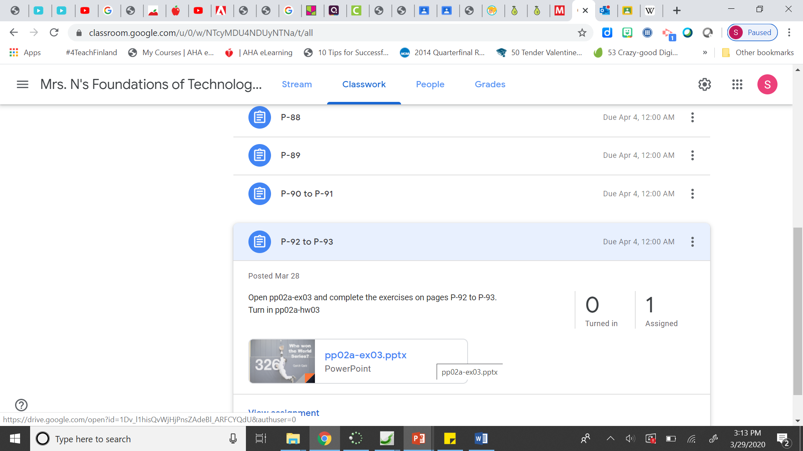
Then click the 3 dots in the top right corner. Click Open in New Window.
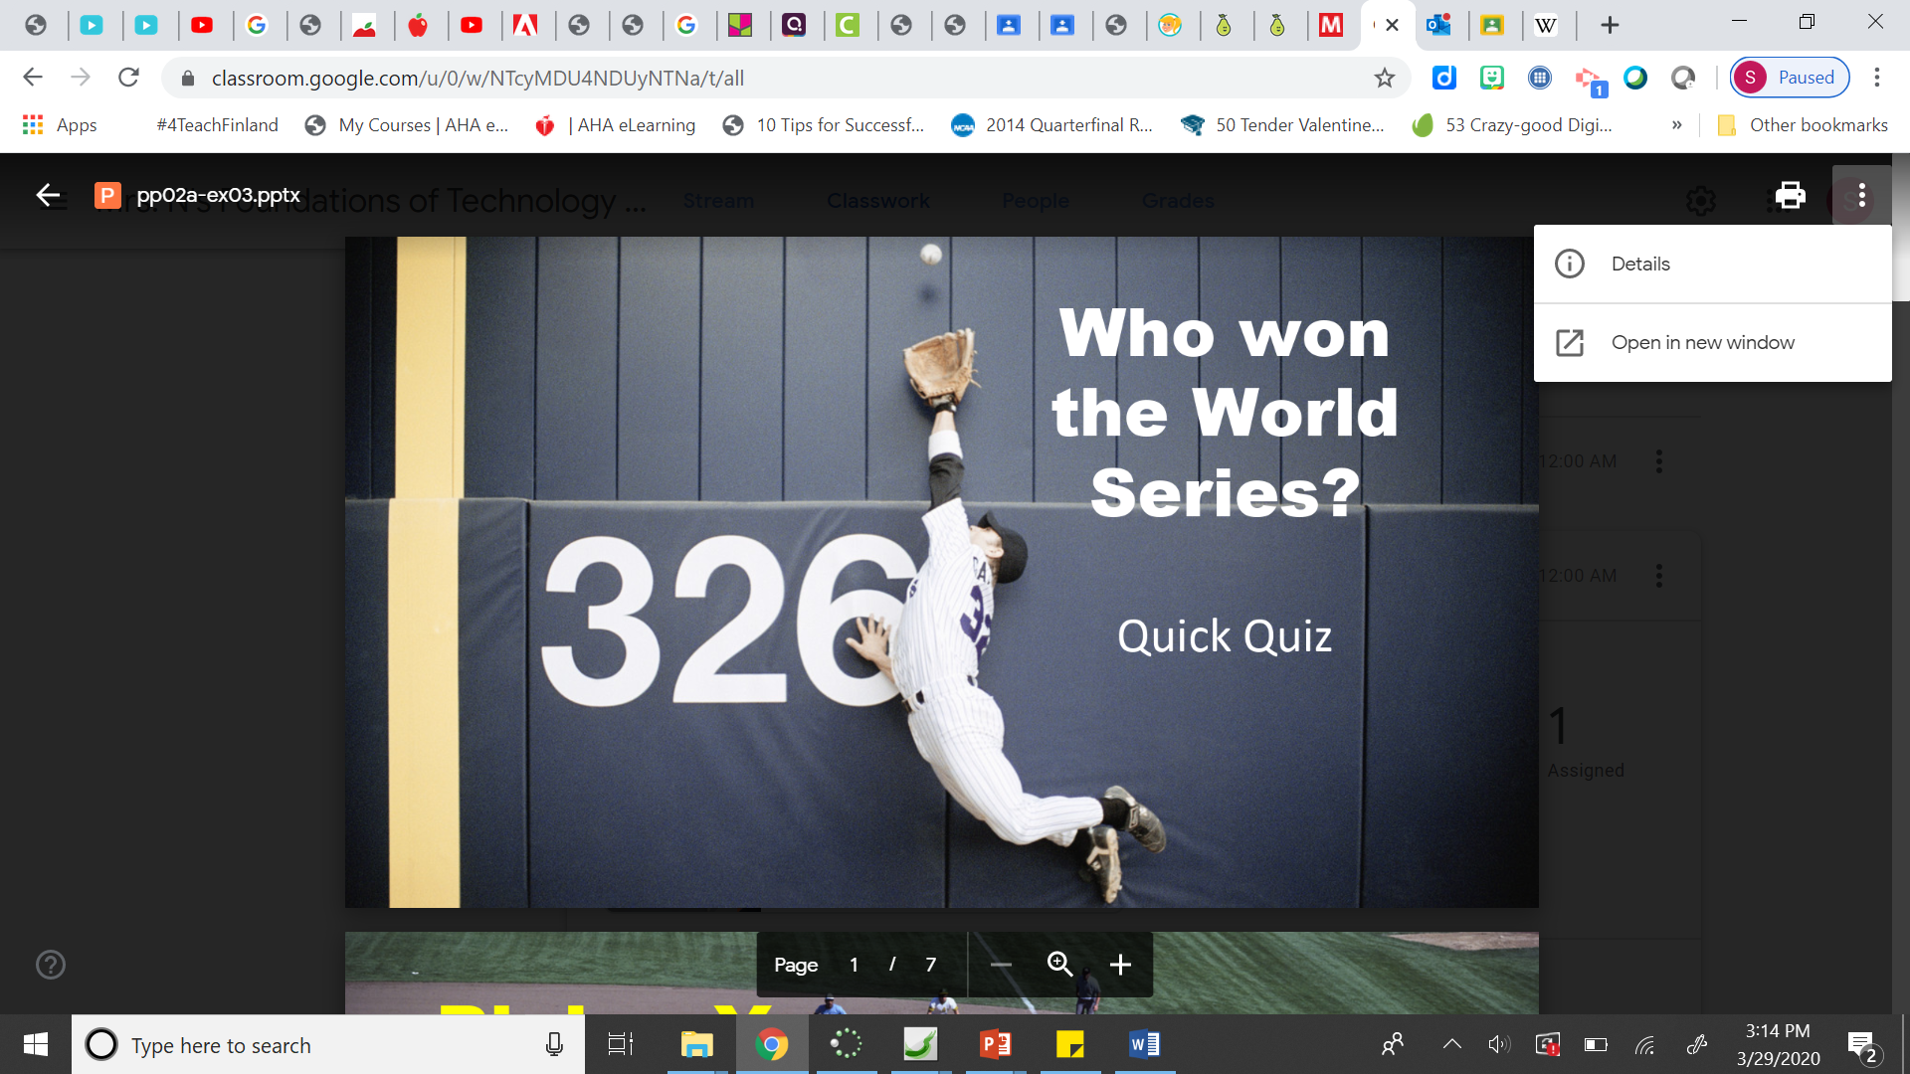
Click the Download arrow.
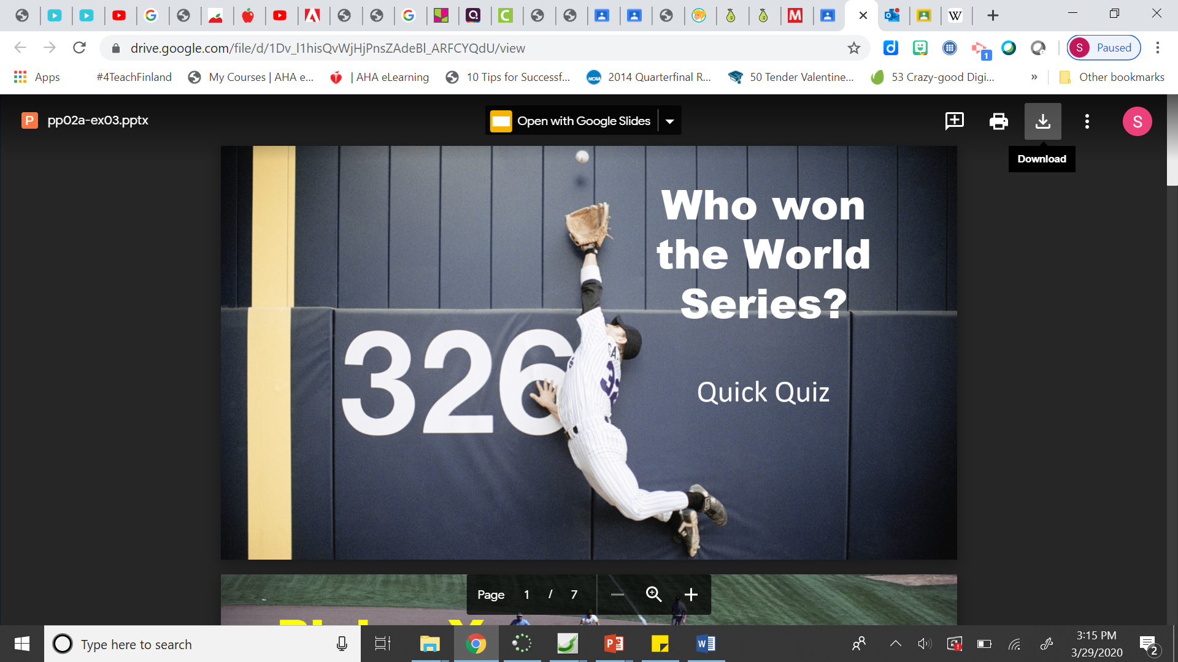

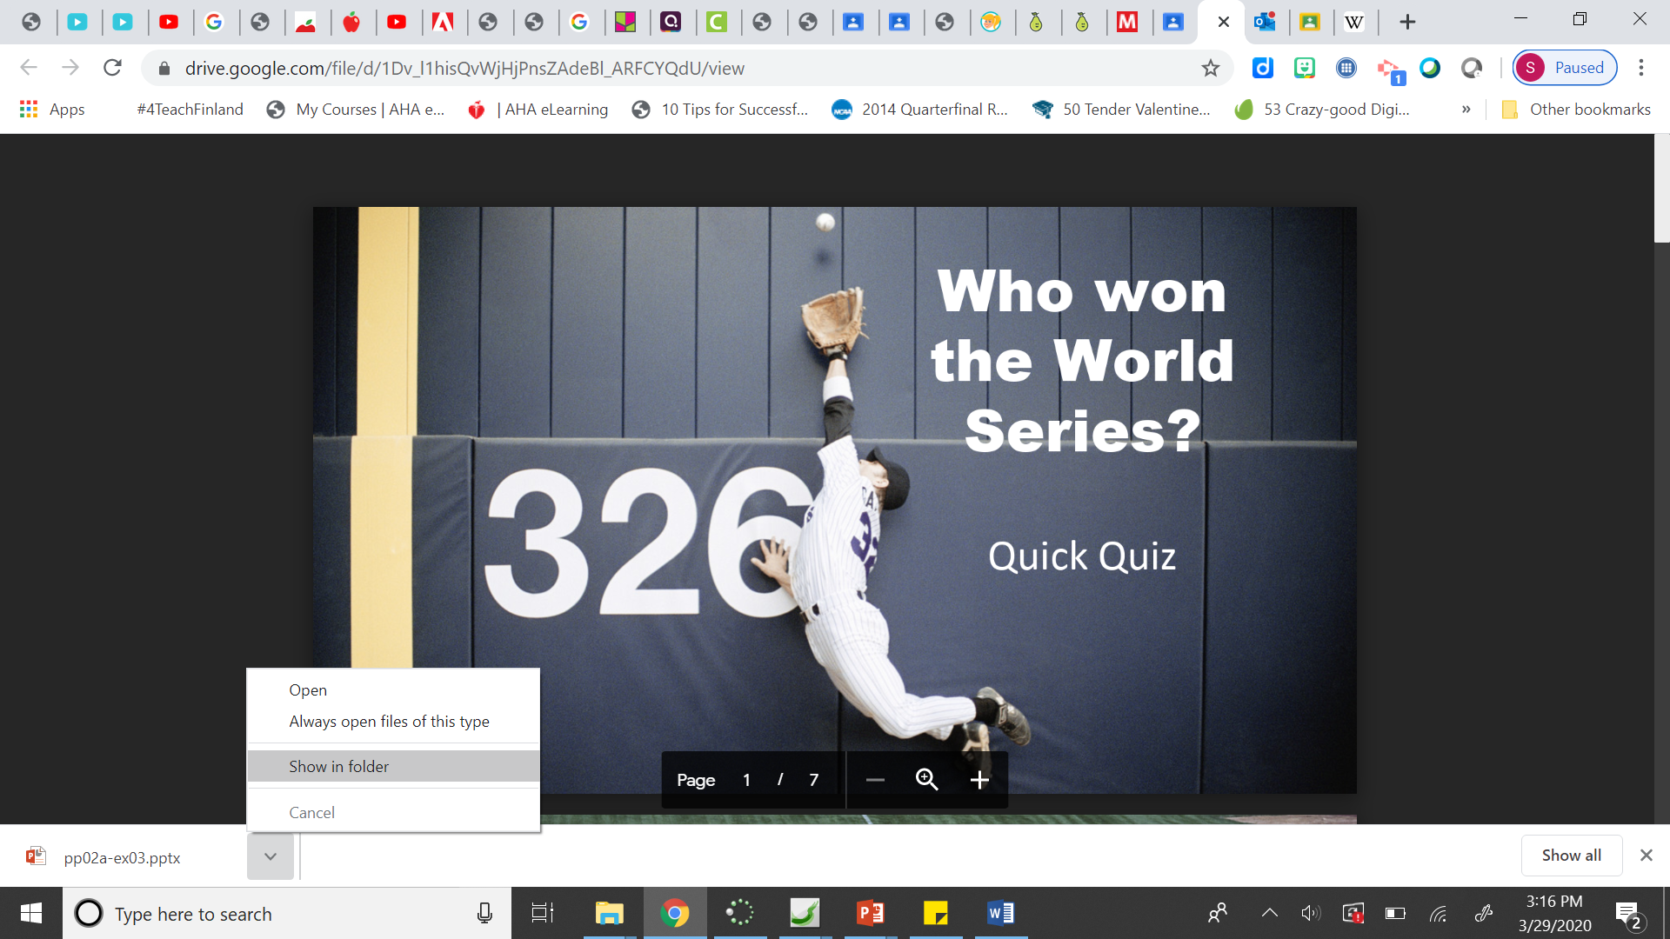
Click the arrow on the downloaded file at the bottom left of the screen in the downloads bar. Choose Show in Folder.

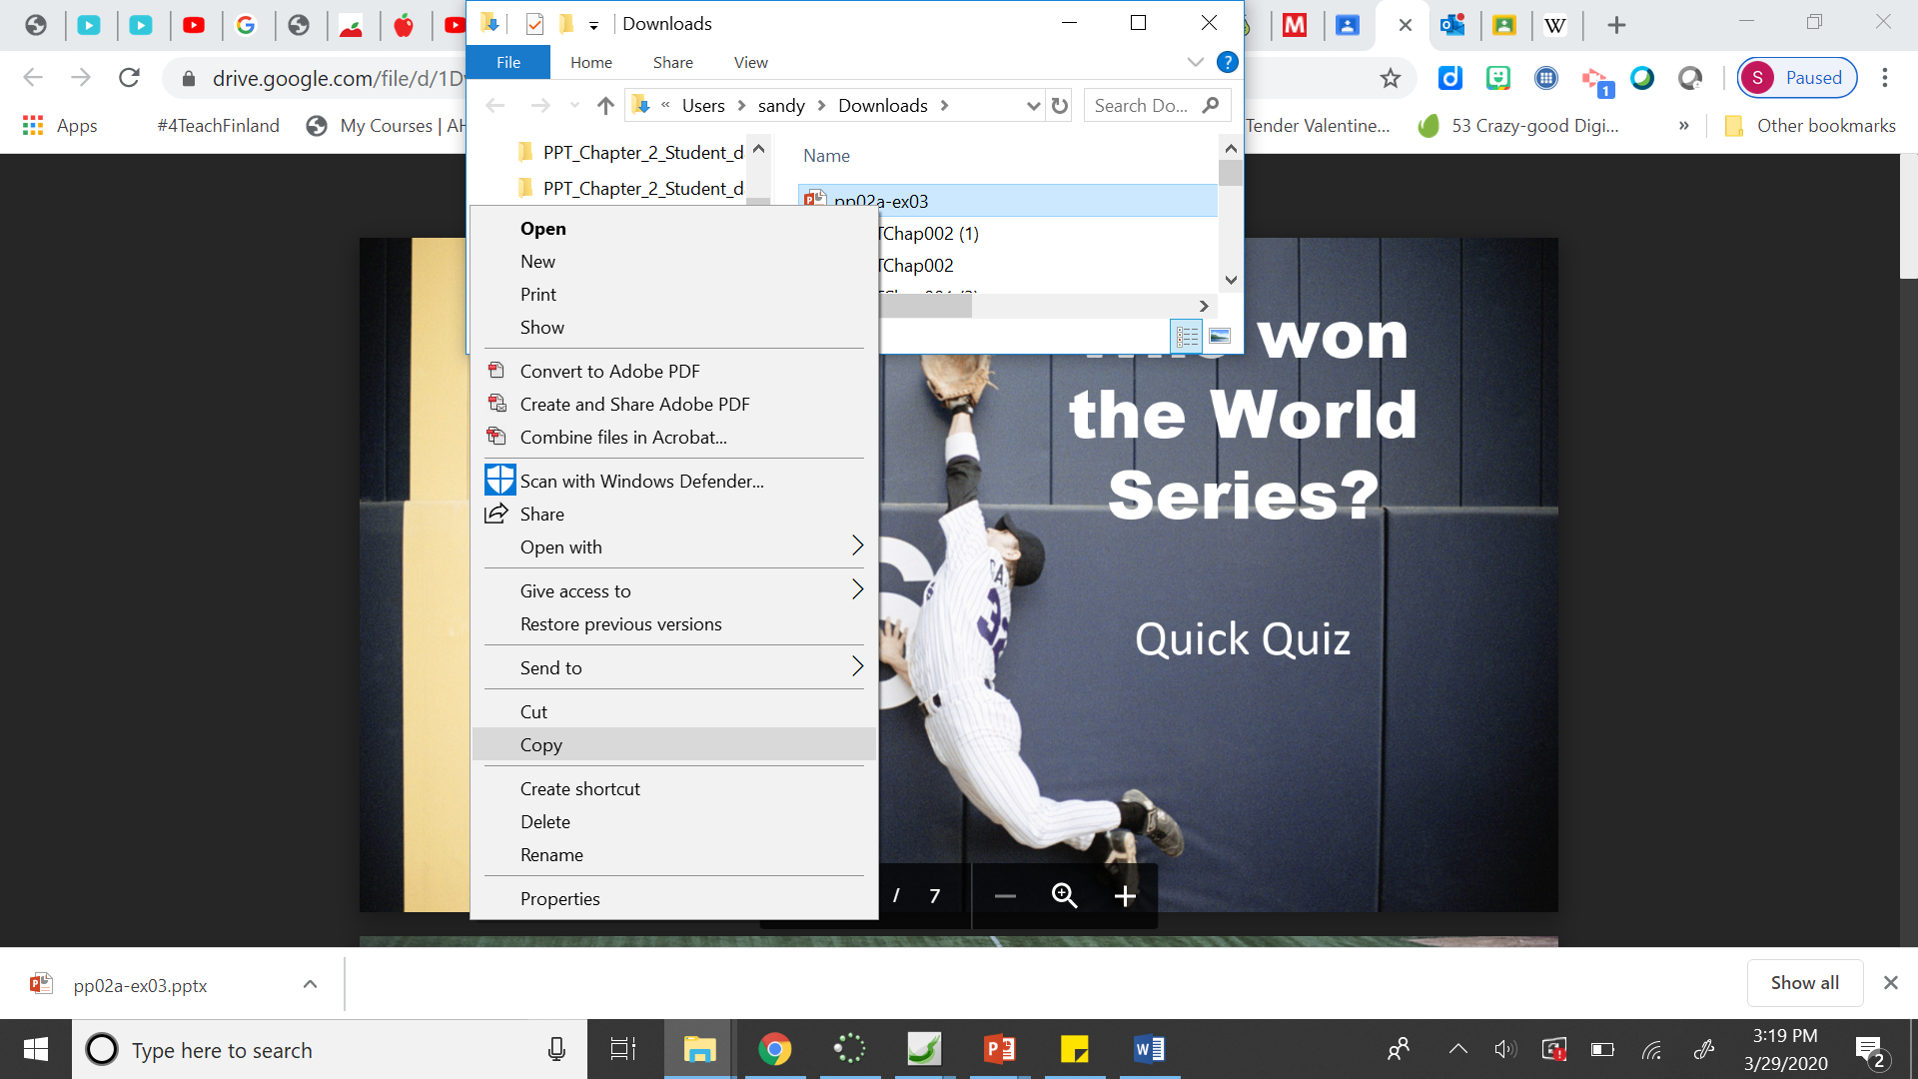
Right-click on the file in the Downloads folder and choose Copy.
Then paste it in your folder on your desktop and rename it.

P-76
To see the numbers they are talking about in the Tip at the top of the page, click on the Animations tab and click Animation Pane in the Advanced Animation Group.
P-79
You need to have your animation pane open - click on the Animations tab and click Animation Pane in the Advanced Animation Group.
#3 – I had to drag it above #7 instead of below #7.

P-80
#4 – See picture below:
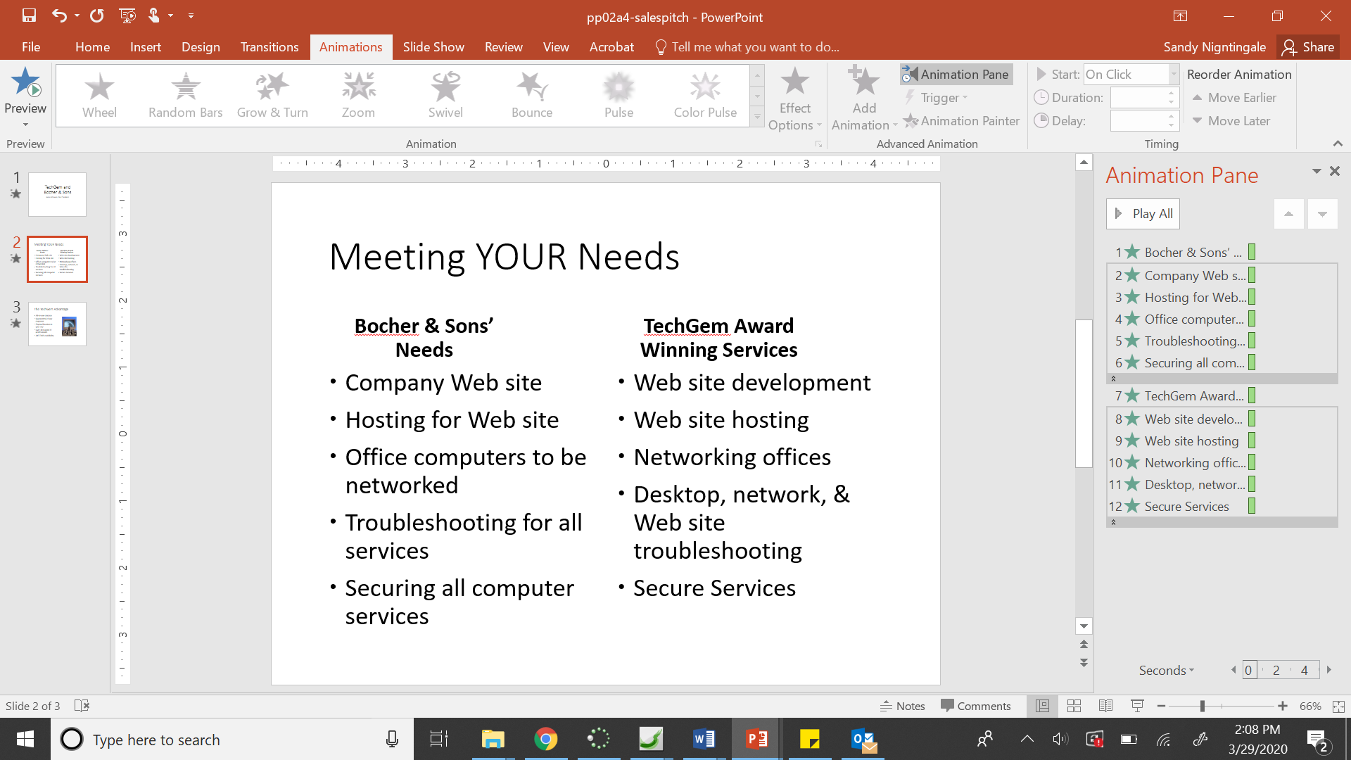
P-89
#5 – I don’t think you can paint the animation in this version. If you can figure out a way to do this, go ahead. Otherwise, just apply the same animation to the bulleted list on slide 3.
P-90
#6 - Here is the website address for the Wikipedia page for forest: https://en.wikipedia.org/wiki/Forest
P-91
#15 – Drag the animation under the animation for the first bullet in the Animation Pane.
Then click the drop-down arrow of the image and choose With Previous.
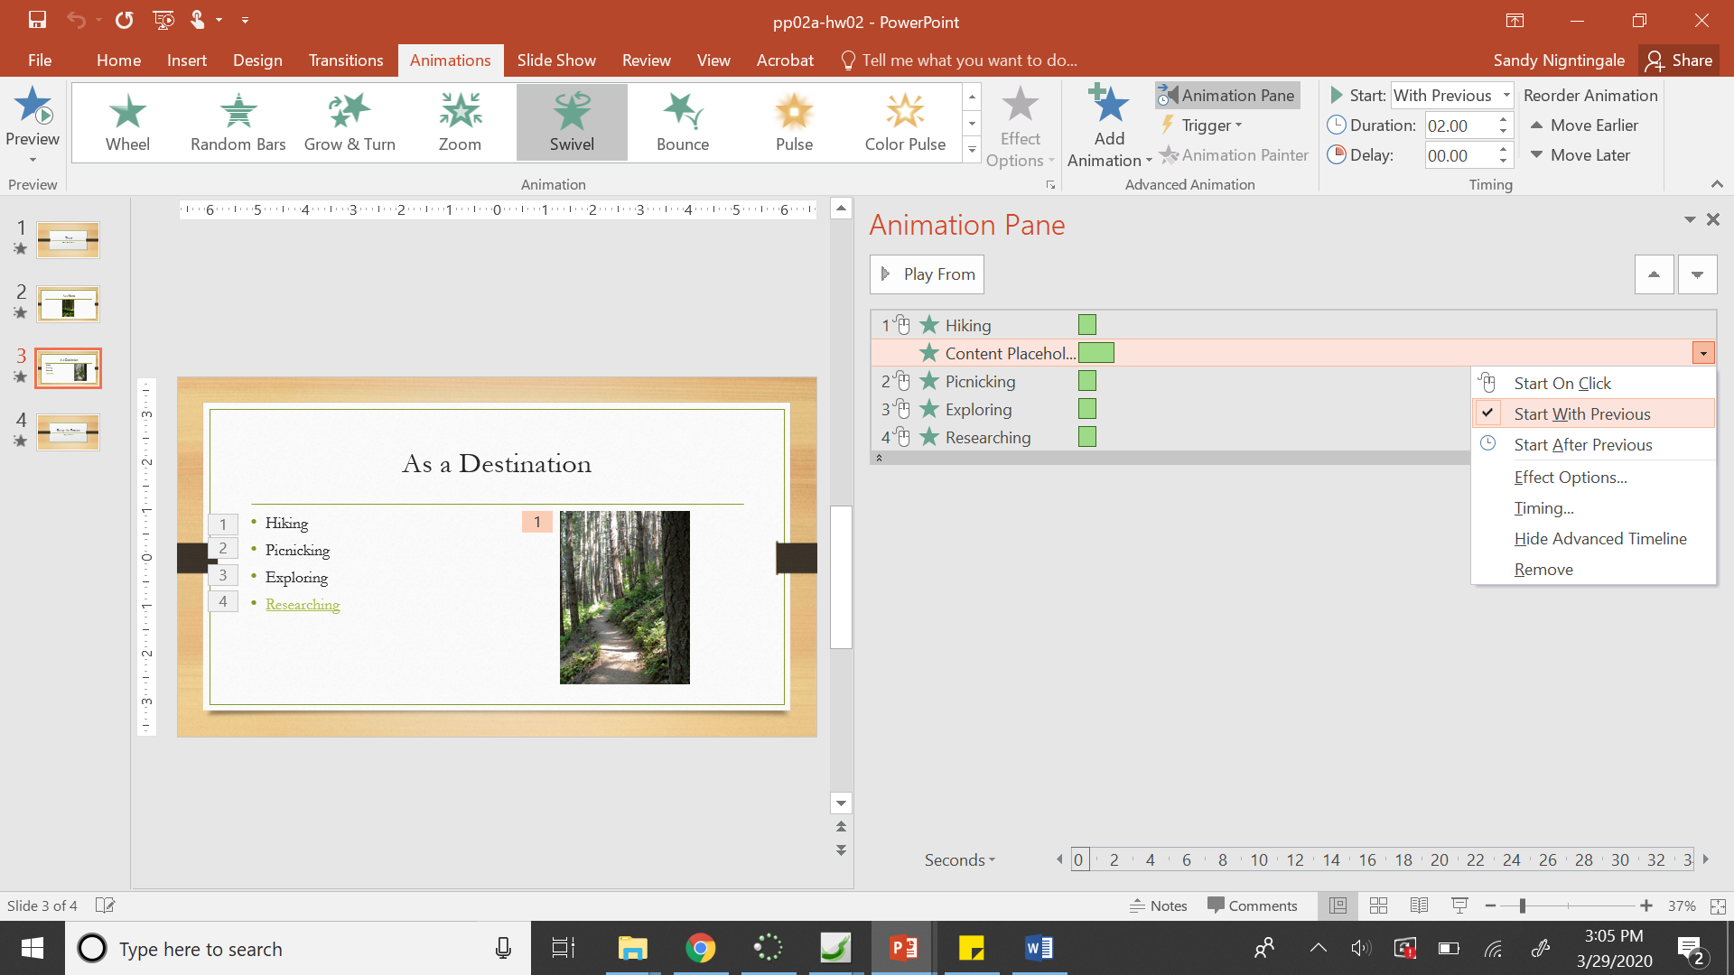

P-92
#8 – I had a hard time finding the Whip Animation, so here is where it was. Add AnimationMore Entrance Effects.
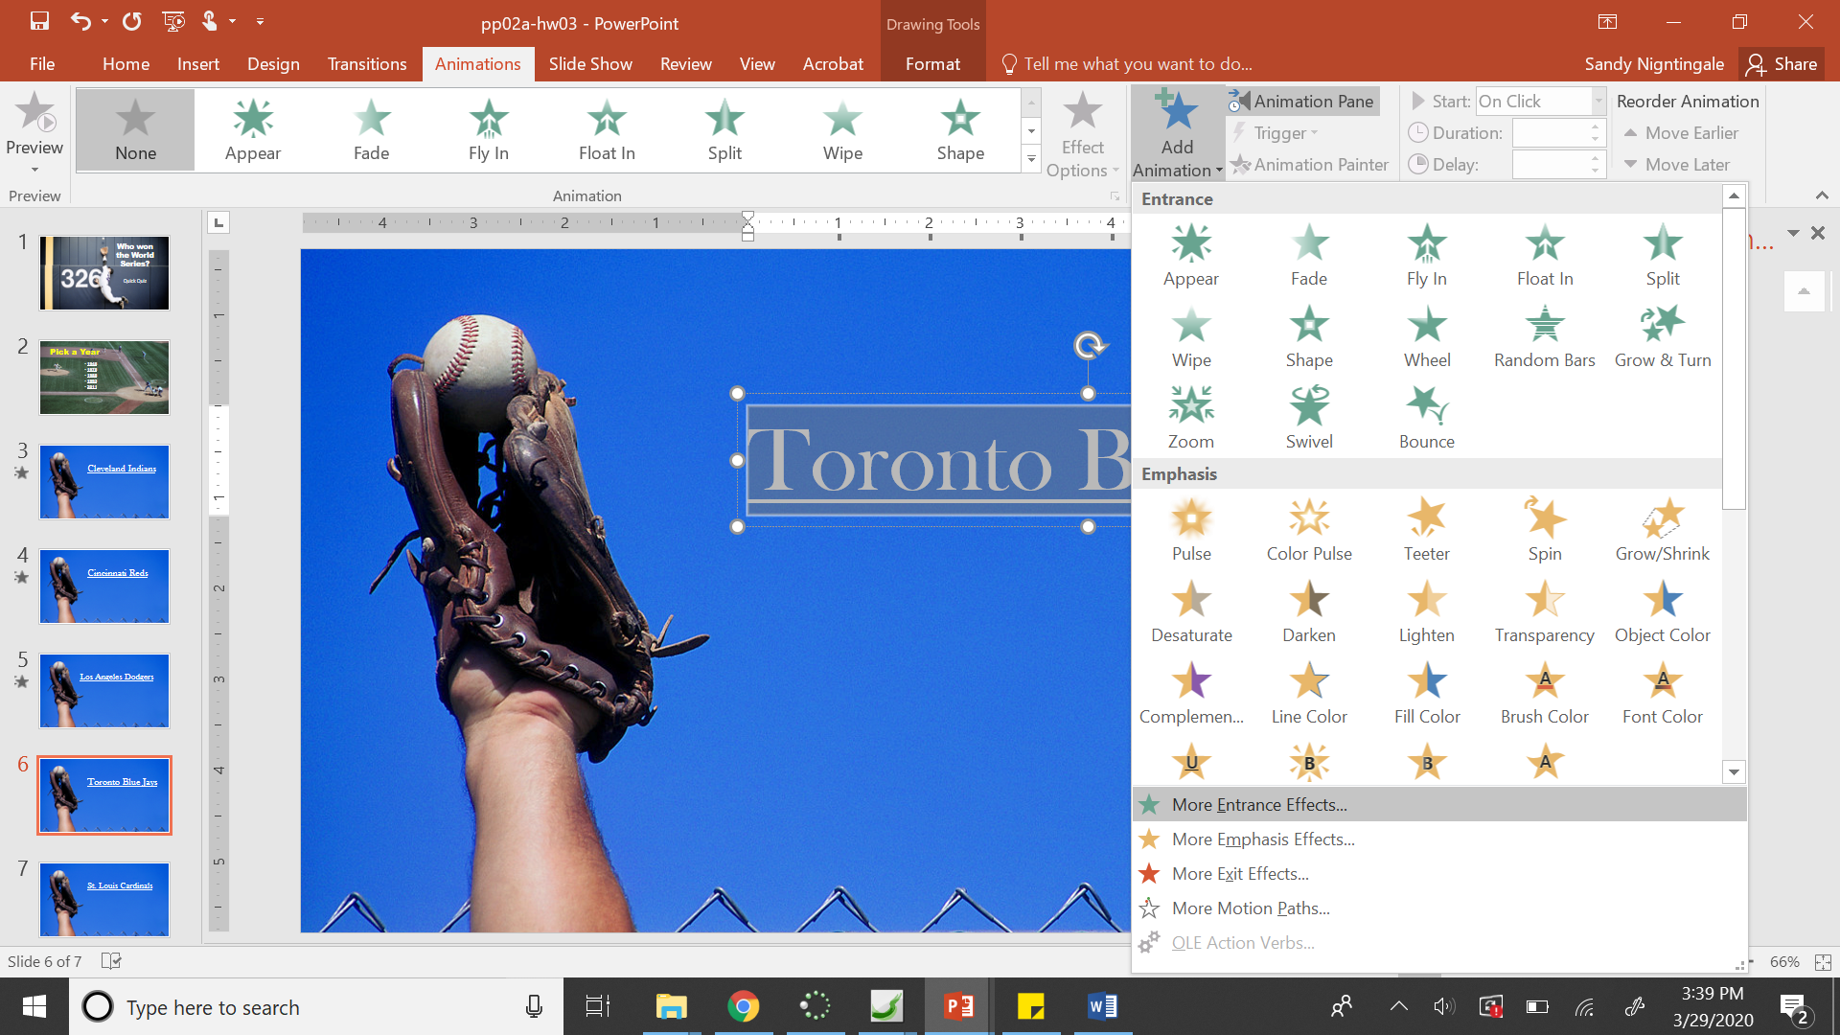
Scroll to the bottom of the list that appears and click on Whip.
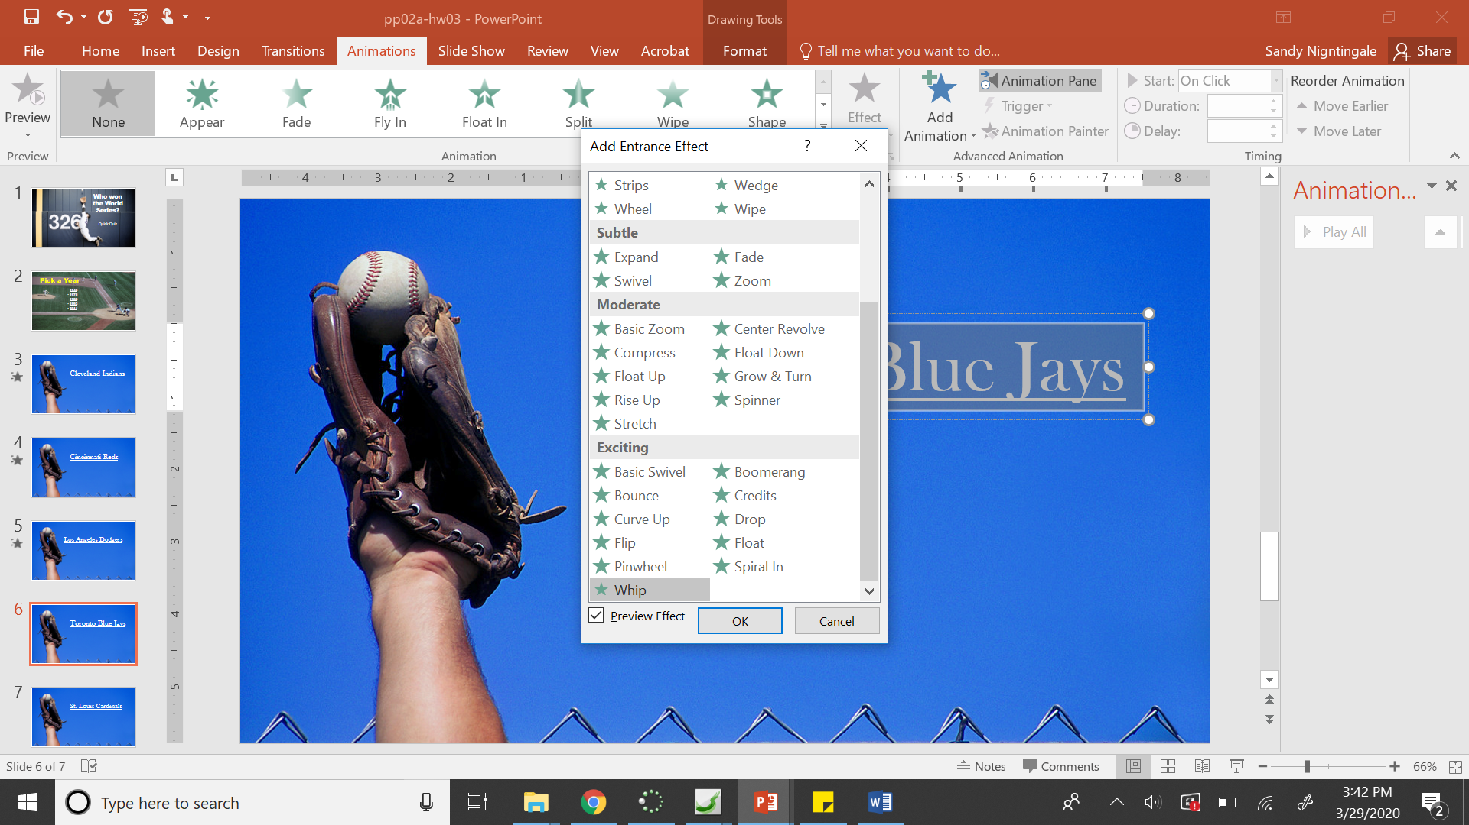

P-93 #10 Title Text
P-93 #10 Quick Quiz TextStart After Previous

