P-29
Step 5 – To get the long dash called an em dash, key two hyphens with no space between and after you type the period at the end, it should change the two hyphens to an em dash.
Step 7 – To copy the text box, you need to click on the border of the text box to make it a solid border, then right-click and choose Copy.
Step 9 - 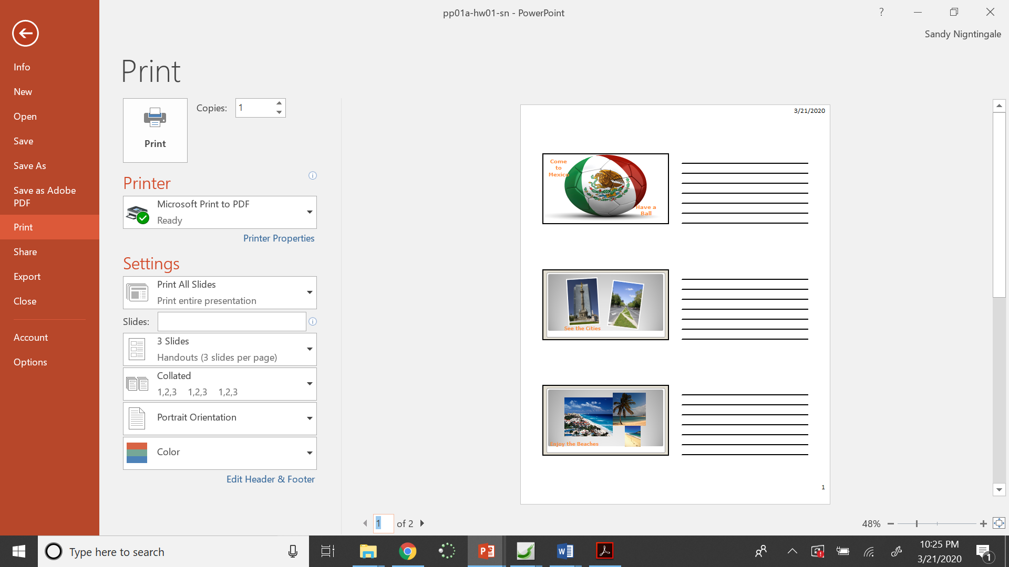
Step 10 – Save the PDF file as P-29-your initials in your folder. Save the PPT file as pp01a-hw01-your initials

P-30
Step 4 – To insert a new text box, click the Insert tab and click the drop-down arrow of the Text Box
button and choose Draw Text Box.
– Click the border of the text box on slide 2 until it changes to a solid border and click on the
Format Painter button. Then click on slide 3 and click on the text box. Delete the bullet by
clicking after it and keying Backspace.
Step 7 – Name the printed file P-30-your initials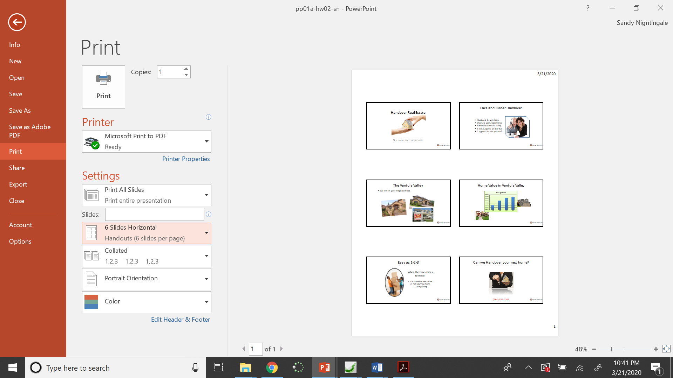
Step 8 – Name the printed file P-30a-your initials
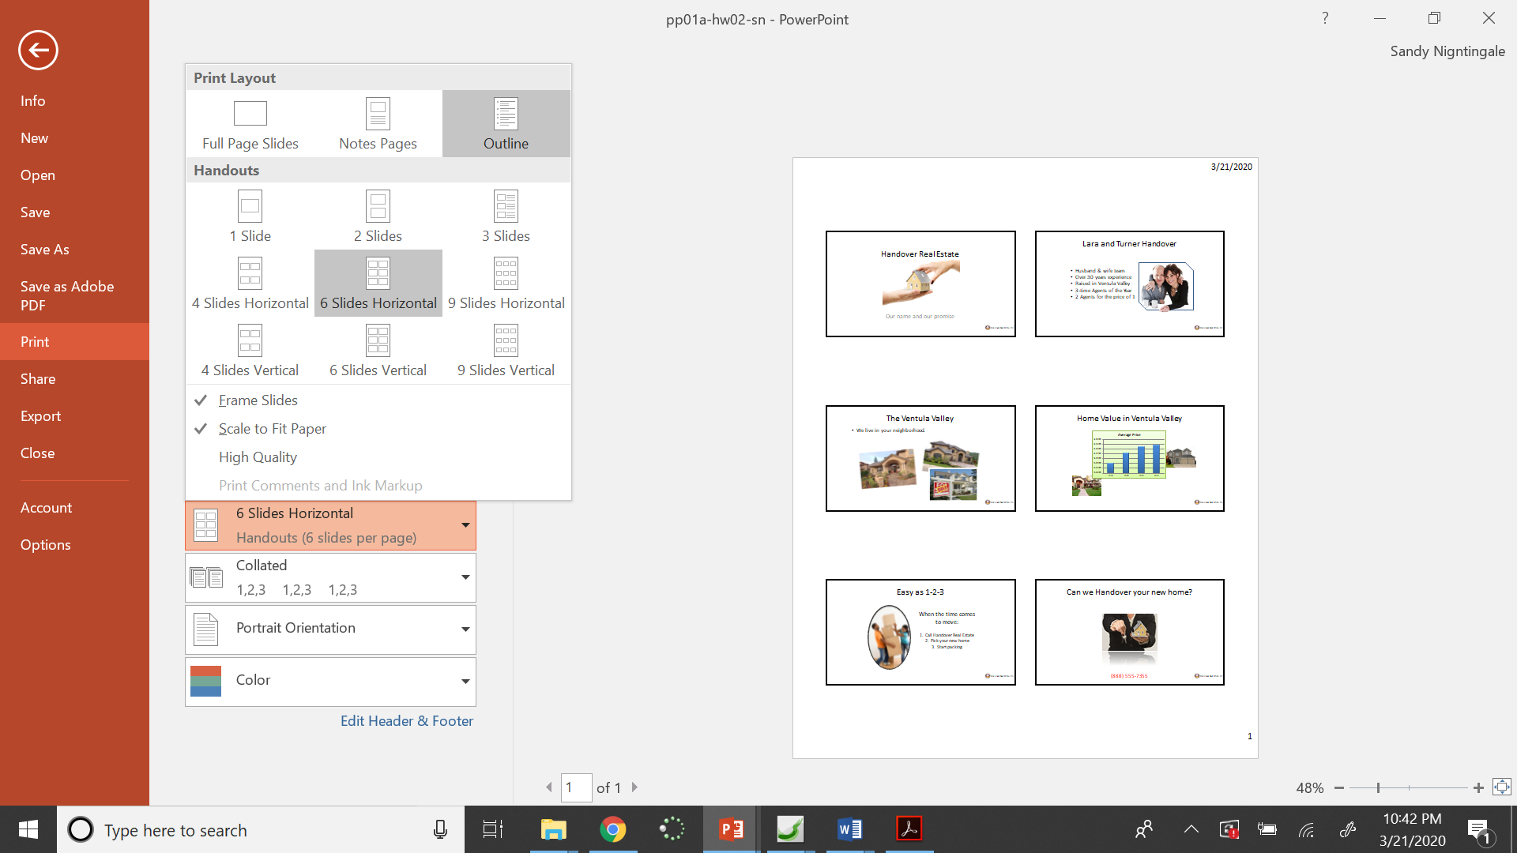
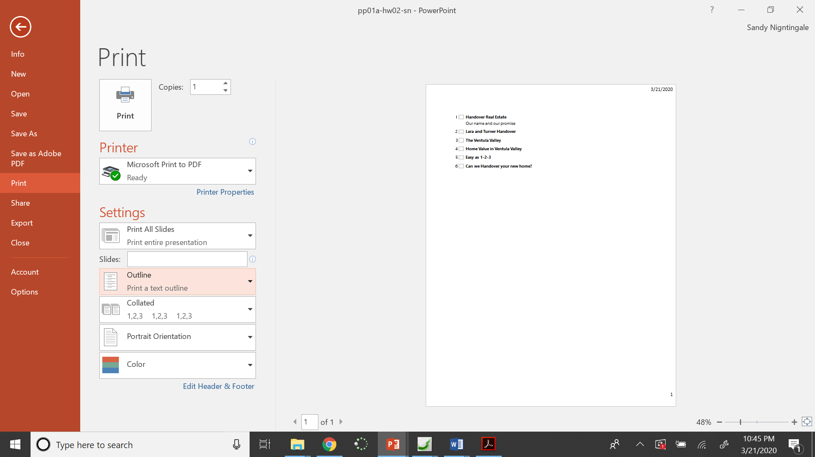
Step 9 – Name the printed file P-30b-your initials
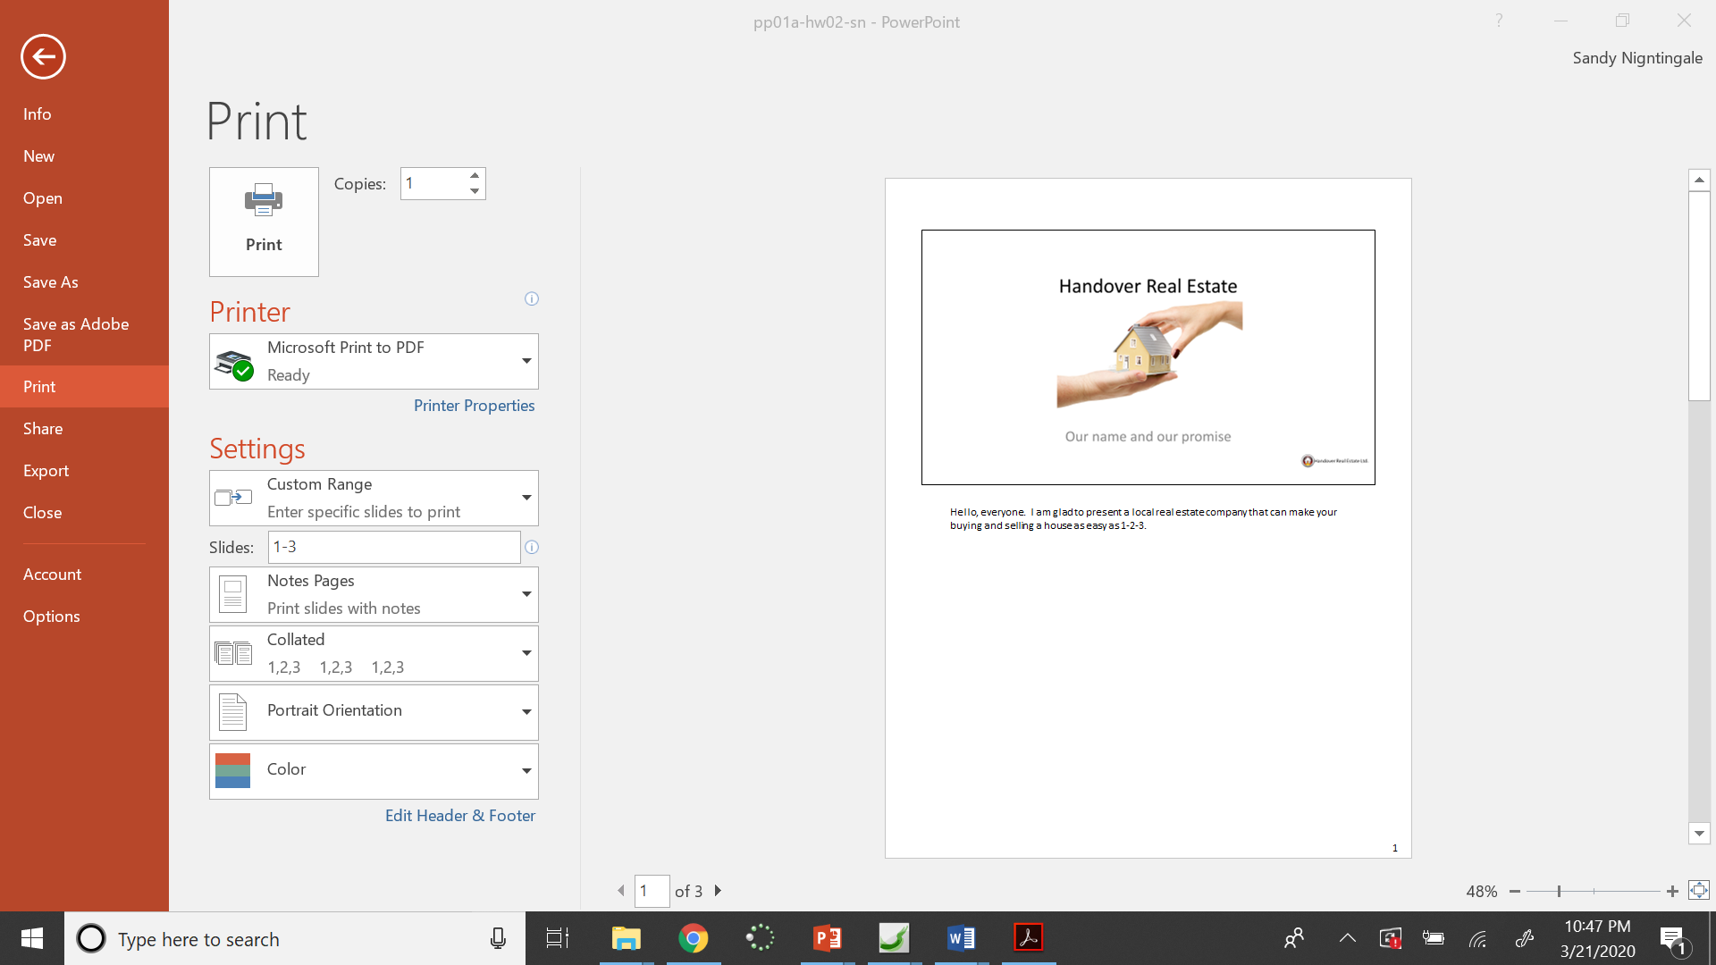

P-31
Step 2
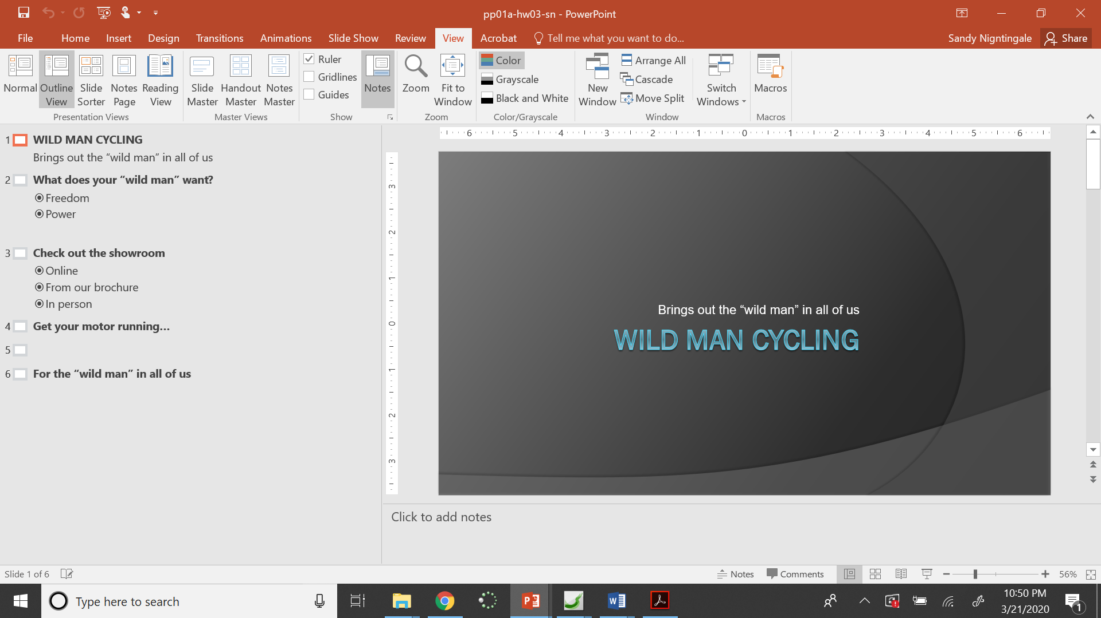
Step 7 – Right-click on slide 1 in the slide outline and choose New Slide.
Step 8 – Enter and then hit Tab to start your bullets.
Step 9 – Save the printed file as P-31-sn
P-34
Step 4 – The picture is in the lesson files for Chapter 1 and then inside the Media folder.
Step 6 – Don’t click on four pictures as the directions say, just choose one.
Step 10 – I couldn’t find the pictures in the book, so just choose ones that are similar in shape so they can be arranged like the book shows. I cropped the one on the bottom left so that it would fit.
P-36
Step 10 – The directions are wrong. Save as pp01b1-construction
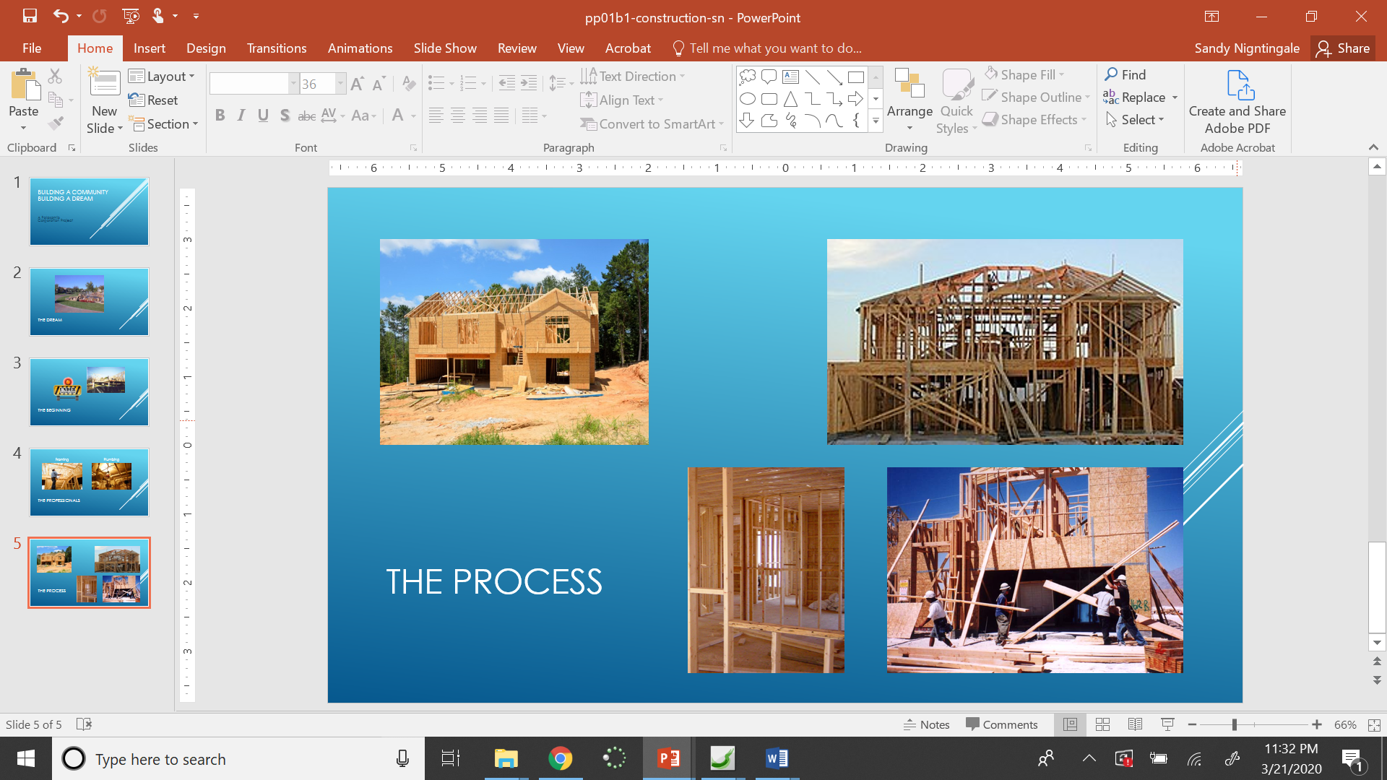
P-44
Step 8 – The Birds in Flight video was sent to you in the email and is also linked on the lesson plans. Don’t search for one
on youtube.
P-47
Step 7 – The deer video we are using isn’t quite as long as the one the book was using so your video won’t quite be 30 seconds long.

P-48
Step 8 – To set the video to repeat automatically, make sure the checkbox for Loop Until Stopped is checked.
One additional step is required to make it work correctly. Click the Animations tab and then click the Animations Pane button.
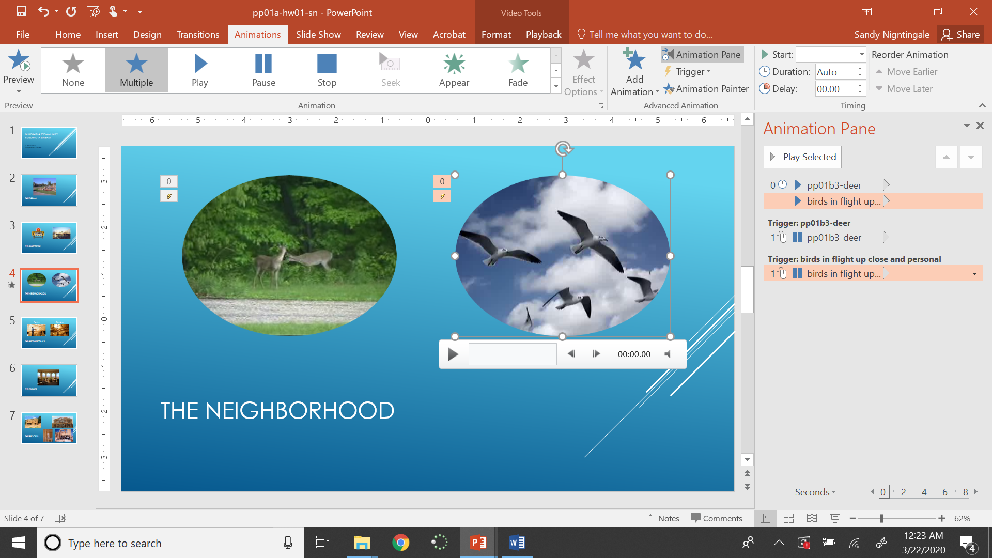
Right-click on birds in flight animation and choose “Start With Previous”.
P-51
Step 3 – Don’t search for the construction sound. There are a couple that were sent to you in the email and linked on the lesson plans.

P-54
#5 –two answers are correct
#7 – a is correct
P-55
Step 6 – I have sent you a mall exterior video.

P-56
Step 3 – I searched for San Francisco trolley to find one of the pictures. I also unchecked Creative Commons. The pictures I used weren’t exactly like the book, but they were similar in shape.
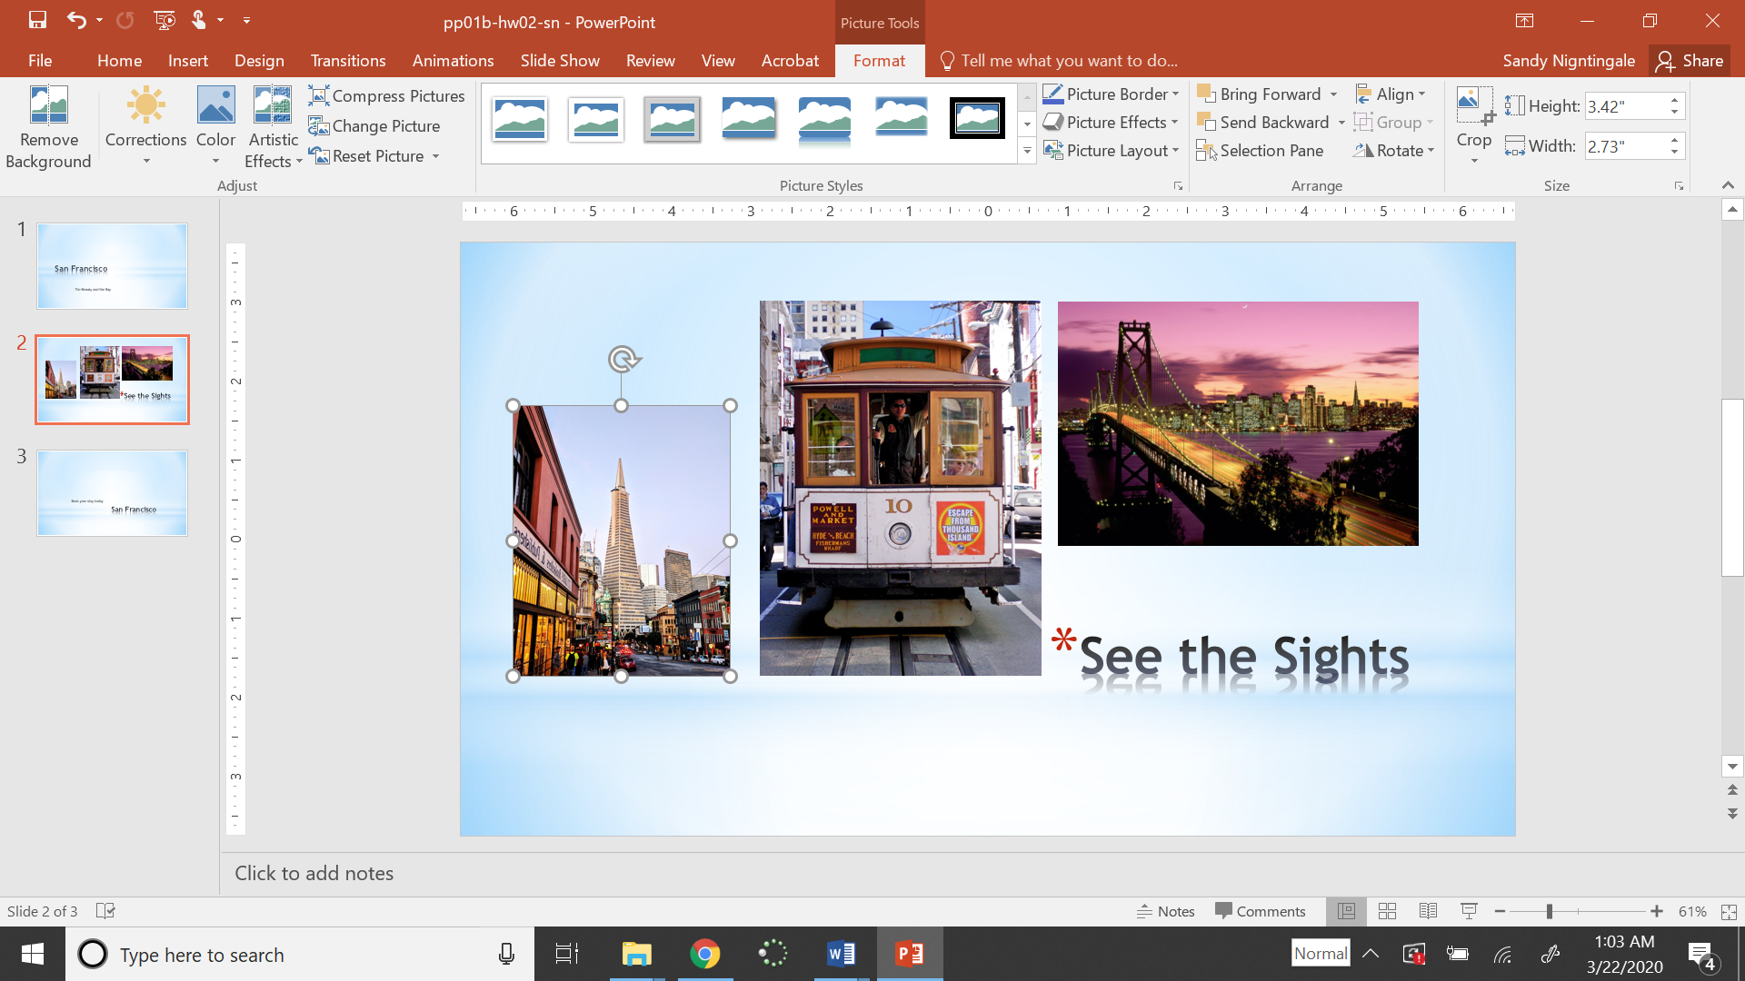
P-57
Step 5 – I have sent you a snorkeling video. Don’t search for one.

P-59
To find penny on graph, I unchecked Creative Commons.
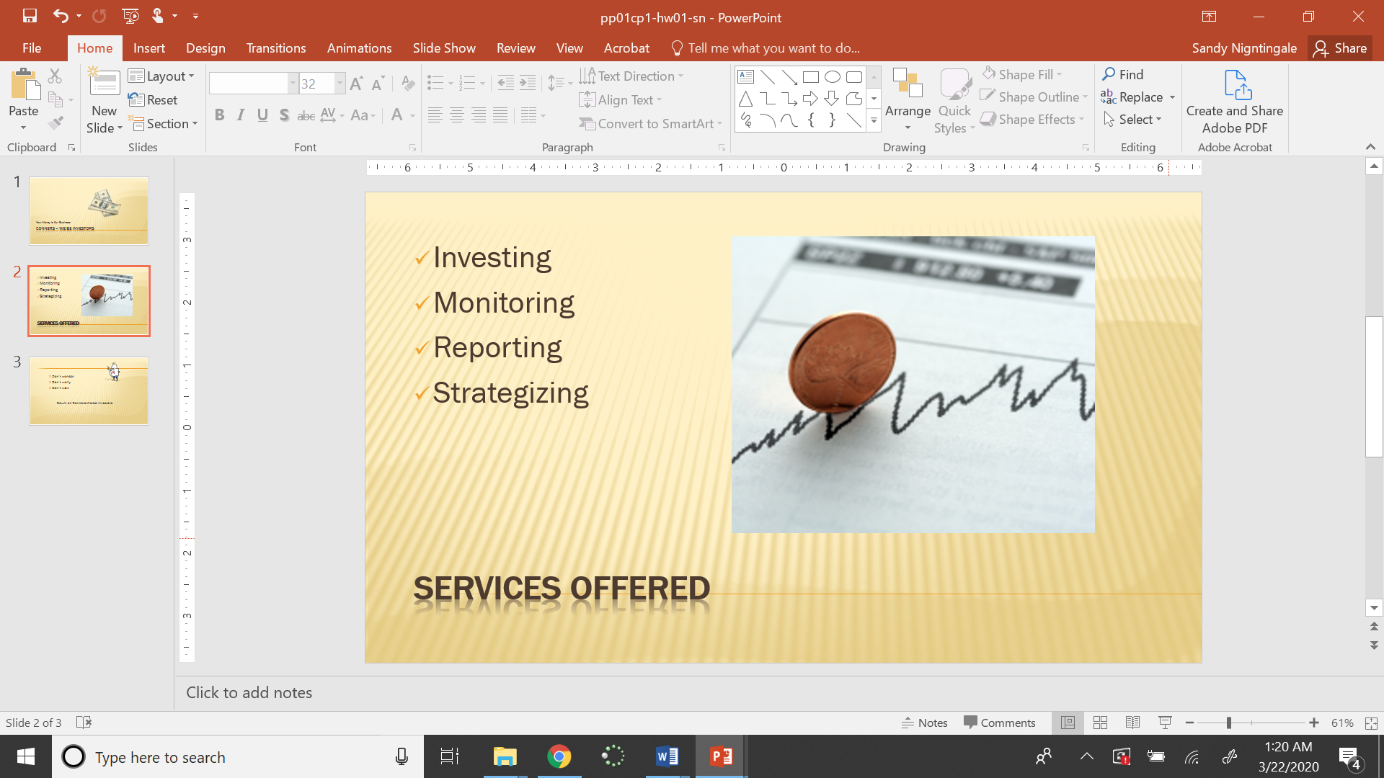
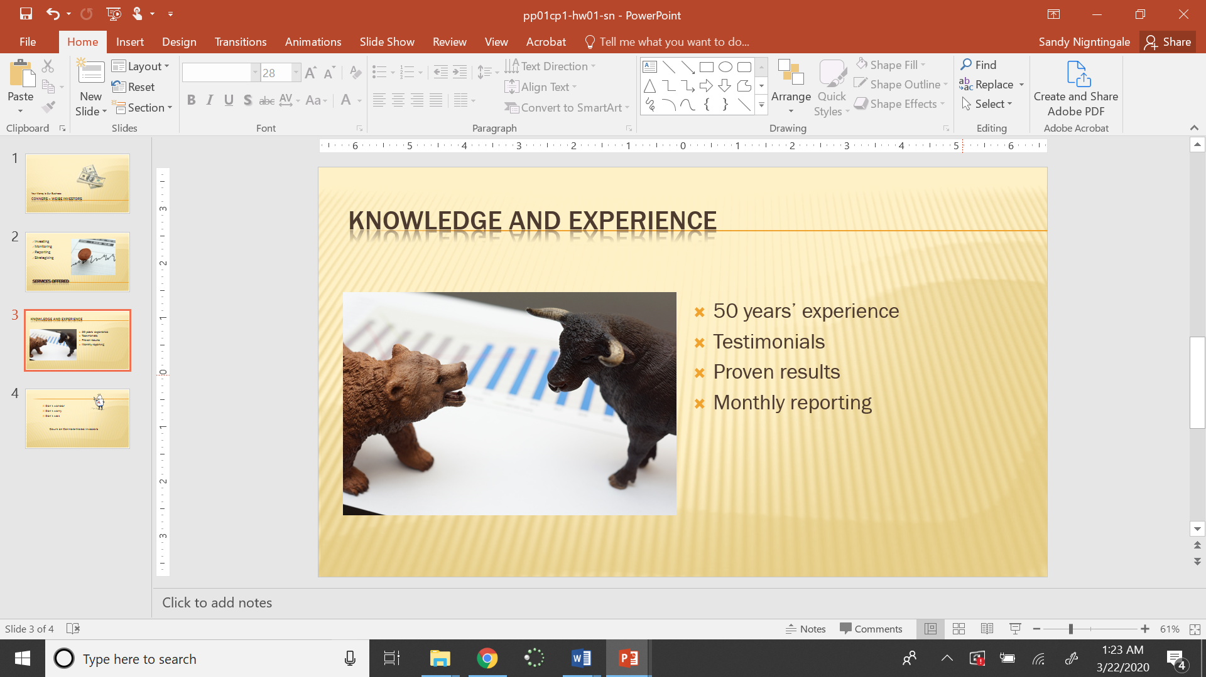

I have sent you a video of Warren Buffett.
Save the printed PDF file as P-59-your initials
P-60
I have sent you a Solar Energy video to use. 