In this tutorial you will learn how to animate your pictures using Photoshop CS2. The result should be similar to this:
This is the image I am going to use for this tutorial. After you will learn how to animate your pictures it will be easy to animate almost all pictures, but keep in mind that you will have to save the images as GIF – so you will lose many details from your photos.
And now let’s make the flames dance!

Step 1
Open the image in Photoshop. You can see that the image has too much black in it. Remove some of it using Crop Tool. After you make the selection press Enter.
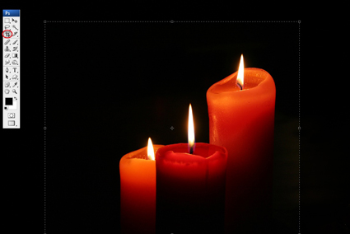

Step 2
Duplicate the background layer.
Click in the duplicated layer. Take the Smudge Tool - you will find it under the Eraser Tool, set the Hardness to 0%. You can see in the image below the difference between 0% and 100% when using this tool.
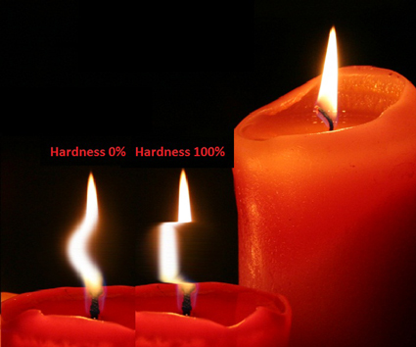
Set the Master Diameter to ~ 70px, put the brush over the flame, hold down the mouse, click and drag a little to the left side, lower the Master Diameter, put the brush a little higher than before, drag a little to the right side, and so on until you think is OK.
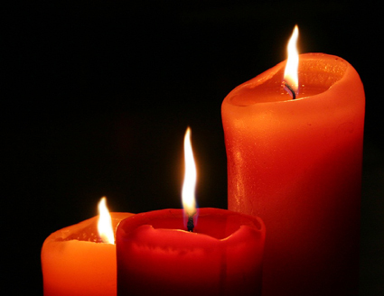
Duplicate the background layer again and put it above all the others. Take the Smudge Tool and do the same as before.
In this way make as many layers as you want.
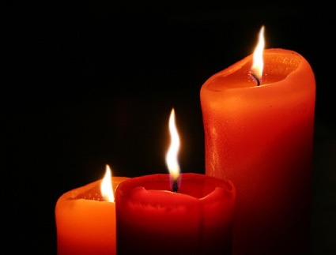
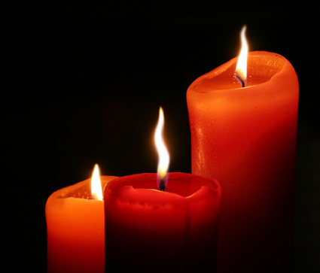

Step 3
And now let’s animate!
Go to FileEdit in Image Ready. See in the picture below what will happen when you do that.
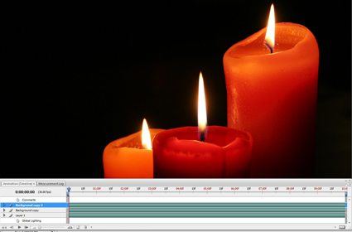
Go to the top-right corner of the animation frames, click on the little arrow and select Convert to frame animation.
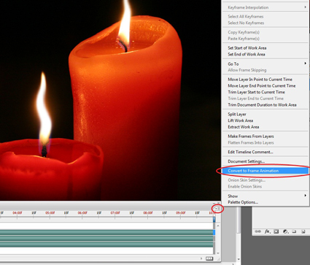
What you will see is this:
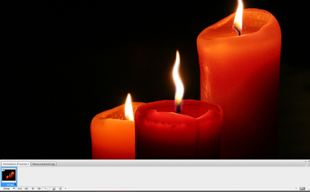

Step 4

Click on the arrow that’s on the Once button and select Forever in order for your slide to repeat on and on. Choose Other if you want to set yourself how many times it will play the slide.
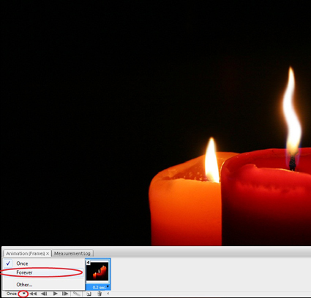

Step 7
Use the optimize panel to set the file type to a gif and the colors to 32.
FileSave Optimized As and save the file as a gif 