Watercolor
- Open image.
- Make a copy of the background layer.
- Choose the top copy layer and FilterConvert for Smart Filters. Click OK.
- Make two copies of the smart layer.
- Name the top one median, the second one dry brush, and the third one cutout.
- Click on the eyes of the median and dry brush layers to make them invisible.
- Click on the cutout layer. FilterFilter Gallery. ArtisticCutout.
Number of levels-4, edge simplicity-4, edge fidelity-3. Click OK
- In the layers panel, change the blend mode to Luminosity.
- Make the Dry Brush layer visible and the active layer.
- FilterFilter Gallery. ArtisticDry Brush. Settings: 10, 10, 3. Click OK
In the layers panel, change the blend mode to Screen or Lighten (depends on the picture).
- Make the Median layer visible and the active layer.
- FilterNoiseMedian. Change the radius to 12 (depends on the picture). Click OK
In the layers panel, change the blend mode to Soft Light
- Save as a psd file and a jpg.

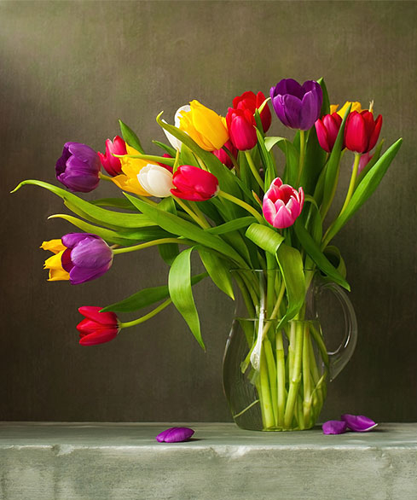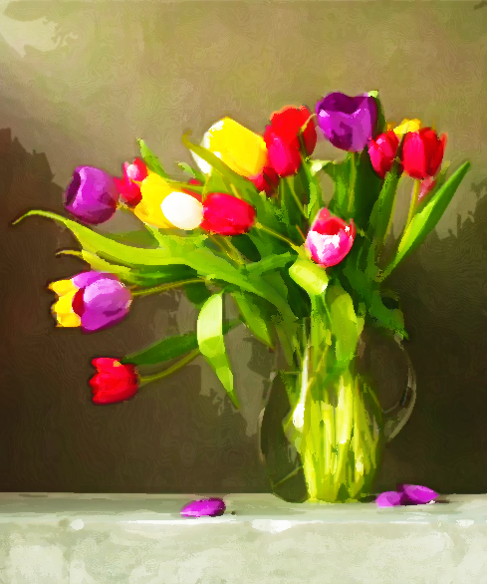
Before After

