Wish to reduce imperfections such as blemishes and acne in your portrait image? Here's how you can quickly do it in Photoshop.
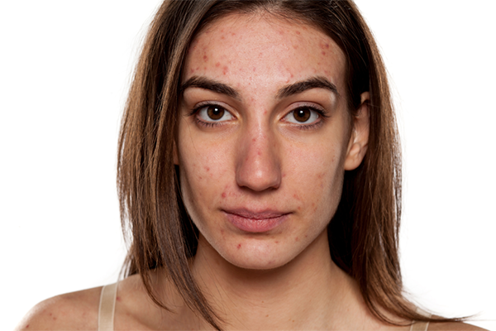
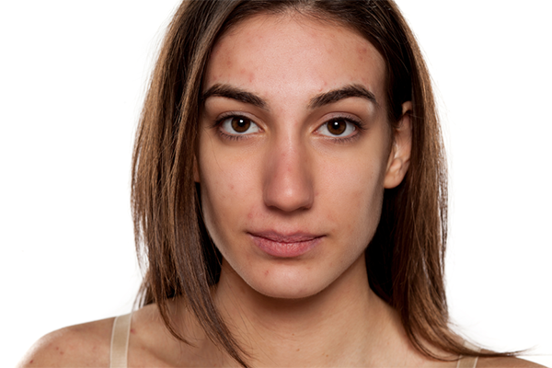
TRY IT IN-APP!
Easily reduce imperfections in your image with a single click.
Smooth skin
Open your image in Photoshop and follow the quick steps below to get the desired result:
- You can access the Discover Panel in Photoshop using the search icon at the upper right of the app workspace. Alternatively, you can use the Cmd/Ctrl + F keyboard shortcut or choose Help > Photoshop Help from the menu bar.
- In the Discover panel, navigate to the Browse > Quick Actions and select Smooth skin.
- Click the Apply button to select the subject in your image.
If you're using the Smooth skin quick action for the first time, click the Download button to download the neural filter to enable this quick action. Then, apply it.
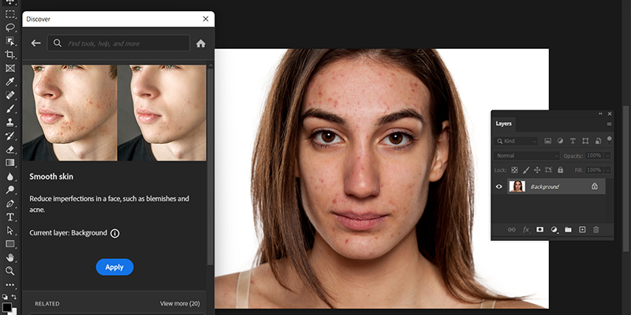
- (Optional) To try on a different layer, select the one your want from the Layers panel and click Refresh to resume.
- Click the Revert button to undo the applied changes. To find more quick actions that you can apply to your image, click Browse more quick actions.
