1. File -> New. Make your canvas 1400 pixels wide and 500 pixels high. If you are planning to print your image, make the dpi 300 or whatever your printer requires. If it is for the web, 72 dpi is fine.  2. Choose your Type tool (It looks like a T on the tools). Choose a large fat font at least 72 pts. or more. Use something like Wide Latin as your font. Key the first letter of your text. If you need to move the letter, move your mouse below the letter until you get the 2-pointed arrow and drag it where you want it. Click the layer in the Layers Palette to commit your text. Change your font or your font size as you need to make a nice big bold text.  If you want your text to overlap as mine does below, do each letter on a separate layer and don't flatten. I actually drew mine using the pen tool. My aim is for kind of a 1965 flower-power look. For the first assignment, I want you to make each letter on a separate layer, then you may try it with them all in the same layer as the next paragraph describes.  It is fine to have your text all on a single layer for this tutorial, but if you are making it all into one layer, don't make the letters overlap! However you do it, use a font that makes bold letters.  File -> Save As.. and pick a location and a descriptive name for your image. Save it in psd format. This preserves the layers and doesn't do any compression so you won't lose image data as you save and resave. Leave this open as you continue the next steps. | 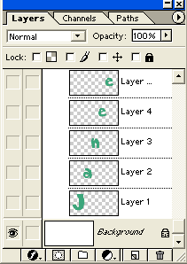
3. Open your first filler image. FileOpenlocate where you have saved your picture that you want inside the letter. Ctrl-a to select all (the whole canvas). Then hold Ctrl and type c. Release both keys. This copies the selection from that image into your clipboard. | 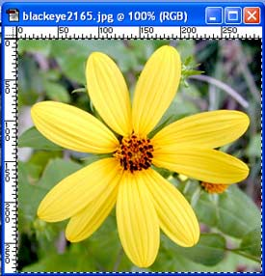
4. Go back to your file with your text and click on your text layer in the layers palette to select the letter that you want to paste into. Then hold your Control key down and in the layers panel, click the layer thumbnail (the little box with the T in it). That will select the letter with a marquee around it.

5. Edit Paste SpecialPaste Into or Ctrl-Shift-V . This should put your image into the shape of the letter.
Look at your layers palette now. You see your filler image there and a mask has been made that allows only the letter part of the image to show. Ctrl-S to save.
6. We can still edit the filler picture. If we don't like how it looks within the letter, we can still change it!  - Choose your move tool and drag it around on your canvas to see what happens to your filler image.  - Ctrl-t or EditTransform to bring up your transformation bounding box. Resize your filler image to see how this works. If you like your change, click Enter to apply the transformation. (If your filler image is bigger than your canvas, you may have to drag your canvas borders wider till you can see your bounding box.)  - If you decide, when you still have your bounding box up, that you want to NOT do this transformation, click the Esc key. If you decide you don't want the transformation after you have clicked enter to apply the transformation, click Ctrl-z to undo or click to a previous stage in your History palette. Photoshop allows us many escape routes!  - In the screenshot to the right, I'm resizing the flower within the letter smaller so that more of the flower shows.  - ImageAdjustHue/Saturation and move your sliders around to recolor it. Click OK if you want to keep your new color or Cancel to go back.  Ctrl-S to save. | 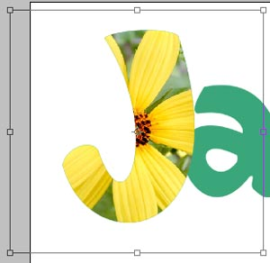
7. Click back on your type layer to accept it. Then you may do the steps over on the next letter.
If you are using the same image as before, you don't have to Ctrl-A and Ctrl-C again, because it is still in the clipboard! Just Shift-Ctrl-V to paste it into the letter you have selected.
8. Repeat for any other letters you want filled with the same image. Ctrl-S to save.
9. Do the other letters with your other filler image(s) just as you did with the first one. Ctrl-s to save.
10. To make the black background, click on the background and, with black as your foreground color (Type D to restore your default colors.), alt-backspace to fill.
11. If you are doing this "Flower Power" look, you may want a funky border as I have made. I did this as follows:
- In the Layers Palette, ctrl-click the text layer. If your letters are all on separate layers as mine are, ctrl-click the first one, then hold shift and ctrl-click the others, one at a time.
- Click your background layer and then click the new layer icon at the bottom of the layers palette. This creates a new layer below all your other work but above your background. Alt-backspace to fill your text selection with black. Since it is under the filled letters so you won't see the black at all. This is a "dummy layer." which we will use to make a layer effect for the text layer. Ctrl-d to deselect.
- Click the little f in the black circle at the bottom of the Layers Palette to bring up Layer Effects. Choose Outer Glow. I used the settings here at the right. (I know that this image is a bit small but the exact numbers are not important.)
Ctrl-S to save.
12. If your letters are overlapping as mine are, you may want the black outlines between the letters. These were done as follows:
- I selected the letters as we did above.
- Then I made a new layer and dragged it above the flower layers in the layers palette.
- I then used Edit-> Stroke .. using black for the color.. and 4 pixels in width. I used the setting "center."
Ctrl-S to save.

