Pop Art Recommended for Beginner to Intermediate Level Photoshop Users
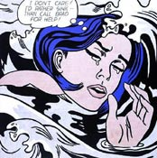
If you are a fan of pop art then you’re probably already well acquainted with the work Roy Lichtenstein. Roy Lichtenstein became one of the leading pop artists of the sixties with his comic-strip paintings. Drowning Girl 1963, shown left, is one of his better known works and is a good example of the design features in his most famous pieces. Notice the thick lines, bold colors, and thought bubble. His work also often included boxed captions and words such as “WHAAM!”, commonly found in comic books.
Benday dots were Lichtenstein’s trademark. Benday dots are a printing process which combines two (or more) different small, colored dots to create a third color. Back in the day, pulp comic books used benday dots in primary colors to inexpensively create the secondary colors such as flesh tone.
You can create the benday dot effect by using the Color Halftone filter found in Adobe Photoshop, however in this tutorial I’m going to show you a way to create a fantastic looking black and white Halftone Pattern. “Why?”, because I like the look of it better.
Due to the vivid colors, the pop art that you will create using this tutorial will look fantastic if you get it printed at your local print shop. If you are going to get it printed, in the beginning change the resolution to 300dpi (Image >> Image Size) and at the end of the tutorial change the mode to CMYK (adjust colours if necessary).
There are 2 parts to this tutorial…

PART 1. Creating the Half Tone Shading

a) Preparing the Canvas
Open your picture in photoshop that is going to become pop art and duplicate the layer called “Background”. (Just click the layer called “Background” and drag it to this icon at the bottom of the layer palette to duplicate the layer.)
Rename this new layer “dots”. (To rename a layer right-click on the name in the Layer Palette and select Layer Properties).
Create another new layer and fill it bright blue using the Paint Bucket tool .
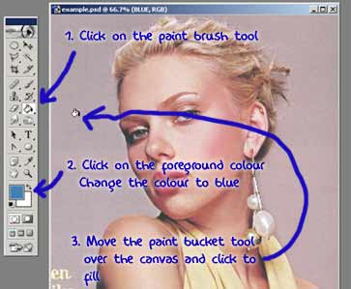
Drag this layer between the two existing layers and rename it something meaningful i.e “blue”. The image below shows what your Layer Palette should look like. This is the basic set up to begin.
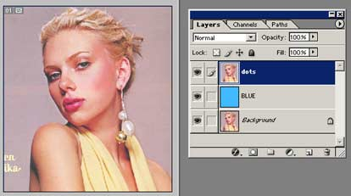
Now working on the “dots” layer we need to clear out all the unwanted parts of the photograph. In this case I want to isolate Scarlett and delete the rest i.e lilac background and bit of text.
To cut out Scarlett I use the Pen Tool. Now to sum up how to use Photoshop’s pen tool in a few sentences isn’t easy…if you have never used the pen tool before, do the PEN TOOL TUTORIAL first.
Remember to make sure the pen tool is set to create a Work Path. See below.
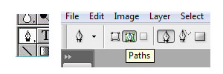
*NOTE: You could use the eraser tool but the results won’t be as professional.
Take the pen tool create a path around the person (or thing) and then make it into selection.
Invert the selection (CTRL + Shft + i) and hit delete.
Deselect (Ctrl + D)
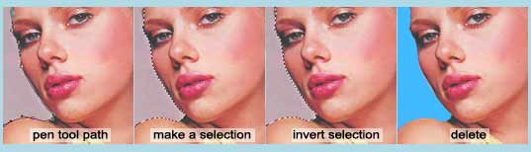

b) Making the Dots
Desaturate the “dots” layer (Ctrl + Shft + U).
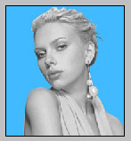
Next adjust Threshold to something dramatic (still working on the “dots” layer).
Image >> Adjustments >> Threshold…
The settings I used are shown in the image below, but you will need to experiment to see what threshold settings works for YOUR image.
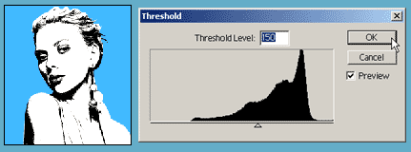
Using Threshold will leave the image looking very pixelated (jagged). So apply Gaussian Blur (approximately a 2-3 pixels should do it).
Filter >> Blur >> Gaussian Blur…
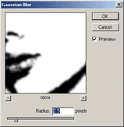
In your Layers Palette right-click on the “dots” layer and select Duplicate Layer…. See image below.
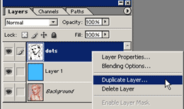
Select New for the Destination Document. Now you will have 2 documents open in photoshop.
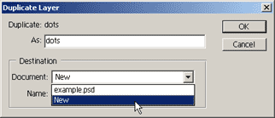
Working on your new document change the Mode to Greyscale.
Image >> Mode >> Greyscale
A dialogue box appears…”Discard color information?”…Click OK.
Now change the Mode to Bitmap.
Image >> Mode >> Bitmap
A dialogue box appears…”Flatten layers?”…Click OK.
Choose Halftone Screen on the Bitmap options window. Click OK. See image below.
It pretty obvious but make sure your output resolution is the same as the input. If yours design is going to be printed then the input should be 300 pixels/inch and your output will be 300. If you’re input doesn’t equal your output the you’ll end up with a change in size!
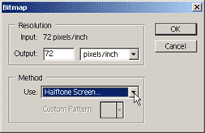
Next appears the Halftone Screen box. Apply the settings shown below. Note you may want to experiment with the Frequency as this decides the size of the dots. Click OK.
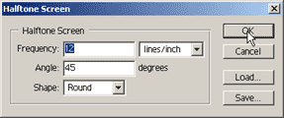
Almost there with the dots. All that’s left is to transfer the dots back to the first document. (See part C).
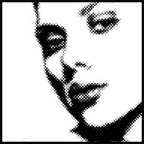
Note if your dots aren’t looking very good you may have forgotten to apply blur or need to apply more blur. The smoother gradient is, the better halftone pattern.

c) Organising
Change the Mode back to Greyscale
A dialogue box will appear…Make sure the size ratio is 1 and click OK.
Now change the Mode back to RGB.
In your Layers Palette right-click on the layer and select Duplicate Layer.
There should be 3 three options as the Destination Document. Choose your original psd (which should be the top one). See image below.
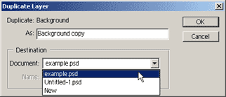
Your Layers Palette should look like the one shown below. You can close the second psd that you created..there’s no need for it now.
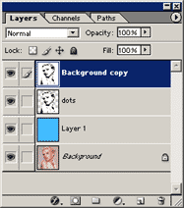
The final step for creating the dots is to create a Clipping Path between the new layer and the “dots” layer.
To create a Clipping Path…hold down the ALT key and move your cursor between the 2 layers in your Layers Palette. When the cursor turns into a “double bubble” (see image below) click to create the clipping path.
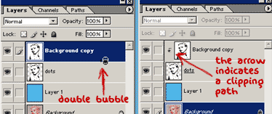
Now link the “dots” and “Background copy” layer. (To link layers simply click one layer then hold down shift and click on the other layer. A little chain icon is shown on the bottom of the layer palette, click it).
Merge Linked layers (Ctrl + E)
If you are using Photoshop CS or later versions instead of linking and then merging the linked layers, after creating the clipping path simply click on the “background copy” layer in your layer palette and then Merge Down.
Your picture should now look like the one shown below..only better because it’s not so small and compressed!
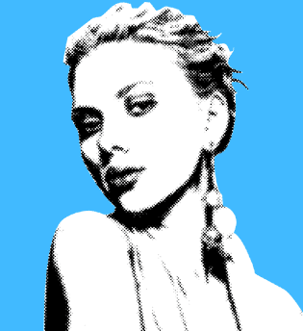
Now is a good time to Save (Ctrl + S) your work.

PART 2. Adding Colour
Having achieved a great looking half tone effect, it’s time to add the colour.
I’m going to use Fill Layers to colour this picture. Fill Layers are great if you are indecisive about your colour palette and fantastic for colour experimentation for pop art.
At the bottom of this page I will briefly show how intermediate level photoshop users can really take their images one step further. Combining this tutorial with my “Turn Photos of People into Line Art” tutorial you can really achieve stunning results.

a) Creating Fill Layers
Duplicate the “dots” layer. Rename this layer “white” and drag it below the “dots” layer in your layer palette.
Adjust the Levels on the “white” layer.
Image >> Adjustments >> Levels…
In the output levels, click and drag the black marker all the way to the right so it is behind the white marker (see image below)
Now the “white” layer is white! Your layers palette should look like the one shown below.
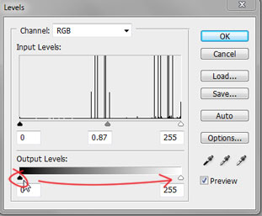
Note: Turn off the visibility of the “dots” layer (click the eye icon) first to see the adjustments on your canvas.
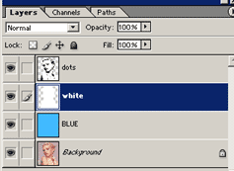
Change the blend mode on the “dots” layer to Multiply.
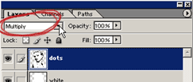
Click on this icon at the bottom of your Layer Palette and select Solid Colour…
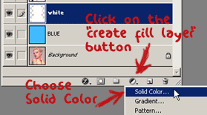
Select a colour in the Colour Picker dialogue box. Click OK. I’ve gone for a red shade to colour her lips. You don’t need to be too picky here because we can change the colour easily later on.
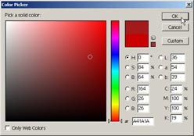
The new fill layer created will appear in your layer window. Right-click and rename the layer e.g “lips” to colour the lips.
Drag the new fill layer below the “dots” layer in your layer palette. See below. Your image is now totally filled with the colour of the fill layer…but don’t worry we are about to fix that.
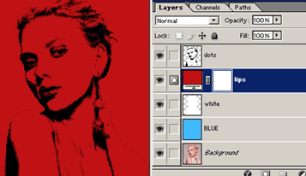
Create a Clipping Path between the “lip” and “white” layer. This will ensure that you don’t colour over the lines ^_^
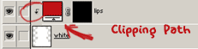
Change the foreground colour to black. Working on this new layer, take your Paint Bucket Tool () and fill the “lips” layer black. The colour disappears…this is because the colour will only show up where there is white on this fill layer.
Note for Photoshop CS5 Users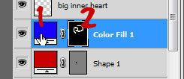
To change the colour of this layer you will double click on the “layer thumbnail” marked with a 1 in the image above. To change where this colour appears on your canvas, click on the “layer mask thumbnail” marked with a 2 in the image above, then using white with your paint brush tool, paint on your canvas where the colour is to appear and paint with black to erase the colour.
Error message: “The fill for this layer must be rasterized before proceeding. It will no longer be editable as a fill. Rasterize the fill?” If this message appears, you’ve made a mistake. Select “No” and click on the “layer mask thumbnail” in your active layer before editing this layer.
Now for the colouring. Change the foreground colour to white. Get your Paint Brush Tool () and start painting where you want to the colour to appear. Use a hard brush with the opacity set to 100%. Make sure that you zoom in when colouring, so that it is nice and tidy!
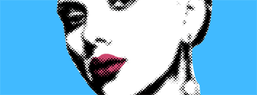
**Fill layers can be confusing if you haven’t used them before.
If you are stuck try reading THIS PAGE, it’s from another of my tutorials where I explain fill layers a little more indepth.

b) More Fill Layers
Repeat the above step creating a new fill layer for each colour/item in your picture. Below is my layers palette.
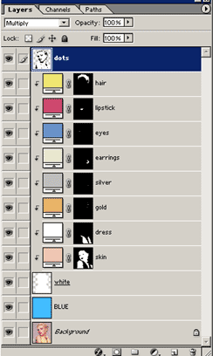
Note how I have used clipping paths on all the new fill layers.
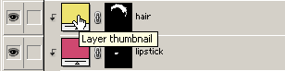
At any time if you are unhappy with a colour that you have chosen, simply double click on the Layer Thumbnail (as shown above) and re-select a colour. Now you have the ability to change the colour of the hair for example, to a whole new colour in a second flat!!
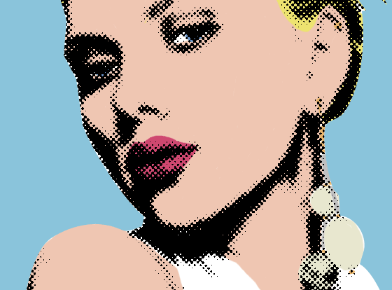
You’re pretty much finished.
You will need to add a caption, or a speech or thought bubble to make this a Lichtenstein inspired piece. Custom shapes have a few speech and thought bubbles to choose from.
The font I used in my finished picture is ANIME ACE.
Try experimenting with the colours too for something really bold.

COMBINING WITH LINE ART TUTORIAL
I’ve had a lot of people ask me how I create half tone shading on my line art pictures. CLICK HERE to see my finished Scarlett Johansson pop art piece.
I’ve written two tutorials on creating the line art.
–Turn Photos of People into Line Art
–Create Basic Line Art form Your Photos
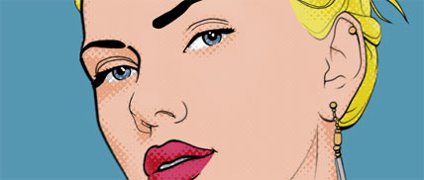
The picture of my layer palette below pretty much explains it all.
Obviously the line art is the top layer.
Duplicate the half tone layer and place it over each colour layer with a clipping path.
Set the mode of the half tone layer to Soft Light (or something similar).
Adjust the opacity of the half tone layer until it looks good.
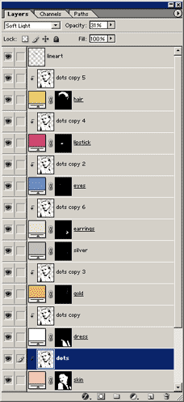
If you are interested in creating the pattern I used for the background of my final Scarlett picture, the pattern is made with a custom shape.
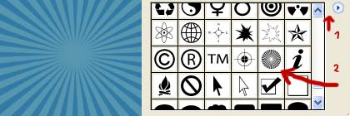
If you are using Photoshop 7, CS or later then you will have it already in your custom shapes (the arrow, marked 2, is pointing to it in the above image). You will need to select Show All to see it (see the image above, click on the area, marked with the 1 arrow to reveal custom shape options -Show All). If you are using an earlier version of Photoshop then you need to make it.

Here are some finished examples.

