Hand Tinting
Traditional Photographic Effects
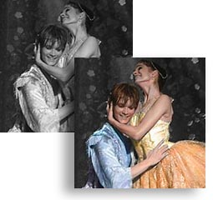
Before the age of color film, when black-and-white photography was the only option, it was common practice for photographers to tint a black-and-white image with colored dyes to mimic real-life colors.
Although we now have all the advantages of stunning color photography, we can still use Photoshop to replicate this technique, and add great charm to black-and-white images.
What we're looking for here is not truly lifelike color, but a decorative and subtle effect. Essentially, we can tint as little or as much of the image as we like, but the effect works best where areas of color are contrasted with the uncolored grayscale image.
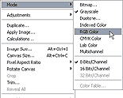Here's how...
Step 1 - Open a suitable image. If the image is in color, go to ImageModegrayscale.
Then convert it back to RGB so we can add color back into it. ImageModeRGB
Step 2 - The color needs to be painted onto a separate layer, so create a new layer (Ctrl+Shift+N). Make sure that this new layer is activated. Set the blending mode for this layer to Color by clicking on the Add a Layer Style Button at the bottom of the Layers panel. (It looks like an f.) Choose Color Overlay. This mode will allow any added color to overlay the image.
Step 3 - Choose the Brush tool and select a soft-edged brush from the Brush Picker.
In the Options bar (right under the menus at the top of the screen), set the brush opacity to 50% and activate the Airbrush icon.
Step 4 - Click F6 on the keyboard to display the Colors palette.
This is where you'll choose all of the painting colors.
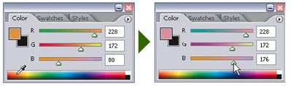
To choose a color, pass the mouse pointer over the spectrum bar and click to choose the approximate color. The colors can be fine-tuned with the RGB sliders above the bar, and the chosen color can be seen in the foreground swatch.
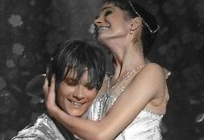Begin by choosing a warm yellow/orange.
Paint over all of the areas of flesh with this color. Remember, because the brush is in Airbrush mode, if we leave the brush in one position for too long the color will build up on the image, so we need to keep it moving at all times.
Vary the skin color slightly by occasionally dragging the RGB sliders. Remember, we only want to tint the image with color.
Now choose a deep brown and paint over the hair of both dancers.
Again, modify the color and tone using the sliders to introduce a little variety.
I've chosen a light blue to paint over the male dancer's costume.
Essentially, we want less color over the lighter parts of the costume and heavier pigment over the darker parts.
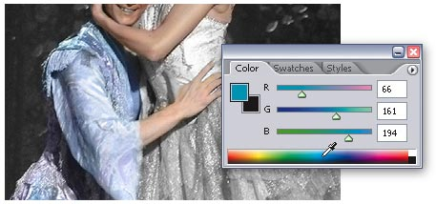
To make accurate application of color easier, zoom into the image and adjust the size of the brush with the square bracket keys on the keyboard.
Step 5 – Repeat the above steps with another color if you choose.
Step 6 – When you are finished adding the color that you want, save the project as a PhotoShop project and save it again as a JPEG.

