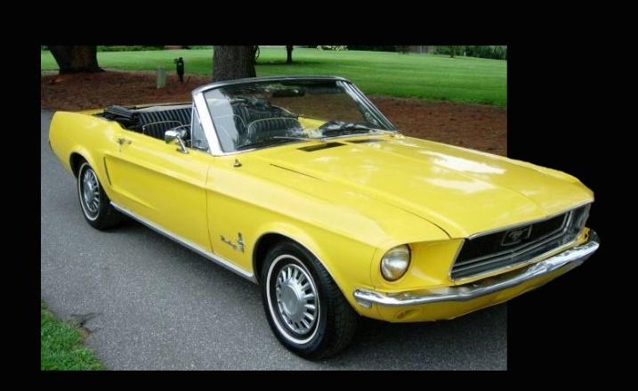
Breaking Out of the Frame
- Open a picture in PhotoShop
- Create a new layer and name it Frame.
- Make sure the Frame layer is active. Click on the rectangular marquee tool and select the part of the picture that you want inside the frame.
- Click the Select menu and choose Inverse.
- Then click EditFill and choose the color that you want your frame to be.
- Create another new layer and name it Break Out.
- Change the opacity of the frame layer so you can see the picture under it, but still see a faint image of the frame.
- Make sure the Background layer is active.
- Click the Quick Select tool and click on the Subtract from Selection option on the options toolbar. Select the part of the picture that will be breaking out of the frame.
- SelectInverse.
- Make the Break Out layer active and EditPaste.
- Change the opacity of the frame layer back to 100% and drag the Break Out layer to the top of the layers.
|

