Photoshop Tutorial – Create 3D Text

Watch this video: https://www.make-your-media.com/how-to-make-3d-text-photoshop-cc-tutorial/
- To create 3D text we first need to add a text layer and write something in the textbox. Select the Text Layer, and click on “3D”, “New 3D Extrusion from Selected Layer”. That will transform the text layer into 3D layer.
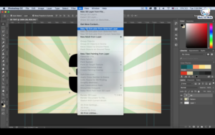
- We can play around with the rotation of the text layer by dragging the X Y Z arrows.
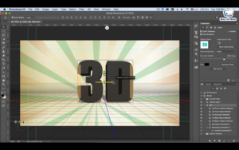
- By clicking on any of the 3D Extrusion Material we can change the properties of the text layer. Like it’s color, Depth, Light etc.
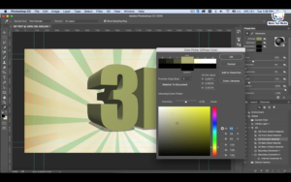
- In order to change the light, click on Infinite Light 1, and move the cursor to the desired location.
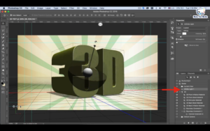
NOTE: If 3D doesn’t work or is grayed out- 3D feature isn’t compatible with 32-bit operating systems, and only available in Photoshop CS6 EXTENDED version, as well as versions CC and beyond. Some video cards may not be supported.

