Healing Brush Tool In Photoshop
In this tutorial, I am going to show you how to use Healing Brush Tool in Photoshop. For the demo, I’ll be removing wrinkles from this beautiful lady’s face.
Unlike the Spot Healing Brush Tool in Photoshop, The Healing Brush is a tool is not only for minute flaws but also works for removal bigger imperfections. To demo this, let’s remove the wrinkles together.
Before I go further, let me show you the final image. Note that I could have easily taken all the wrinkles out but that would’ve made the image look unnatural.

Before

After

What Is Healing Brush Tool In Photoshop?
The Healing Brush tool in Photoshop is a brush tool that creates a pattern on the brushed area either by using Photoshop’s Content Aware technology or by matching its nearby pixels.

Where Is Healing Brush Tool Located In Photoshop?
You can activate this tool either by grabbing it from the tool panel or pressing Shift+J again and again until it comes.
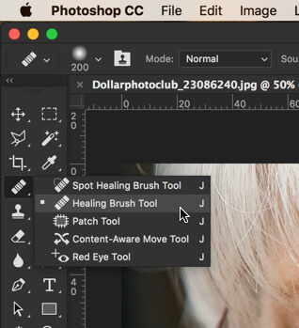

Step 1: Activate Healing Brush Tool
As shown above, you need to activate it by either grabbing from the tool panel or press Shift+J again and again until it comes.

Step 2: Select Source
To use the Healing Brush Tool, you need to select the “Source” first. By choosing the source, you are telling Photoshop that you need this area to be used to cover the flaws.
In the below image, I need to use the area on which I have placed the cursor. Now, when I remove the wrinkle, Photoshop will know that it needs to take this part as a reference to remove the wrinkle.
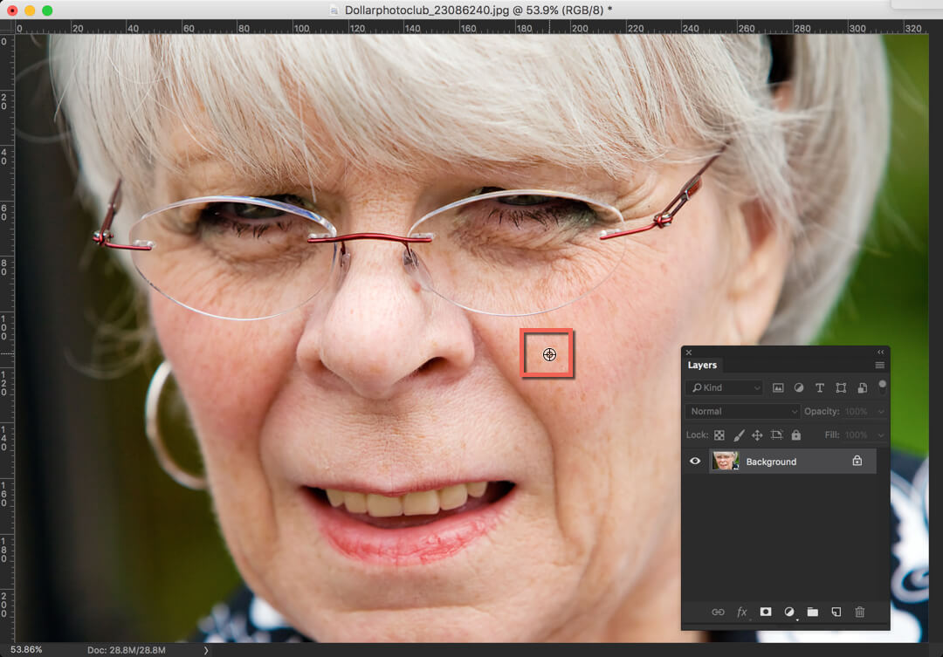
To select the source, you need to hold down Option/Alt key.

Step 3: Brush On The Flaw
Create a new layer so that you are doing non-destructive editing. Now brush on the flaw. In the below image, the blue rectangle shows our brush and yellow rectangle shows our source.
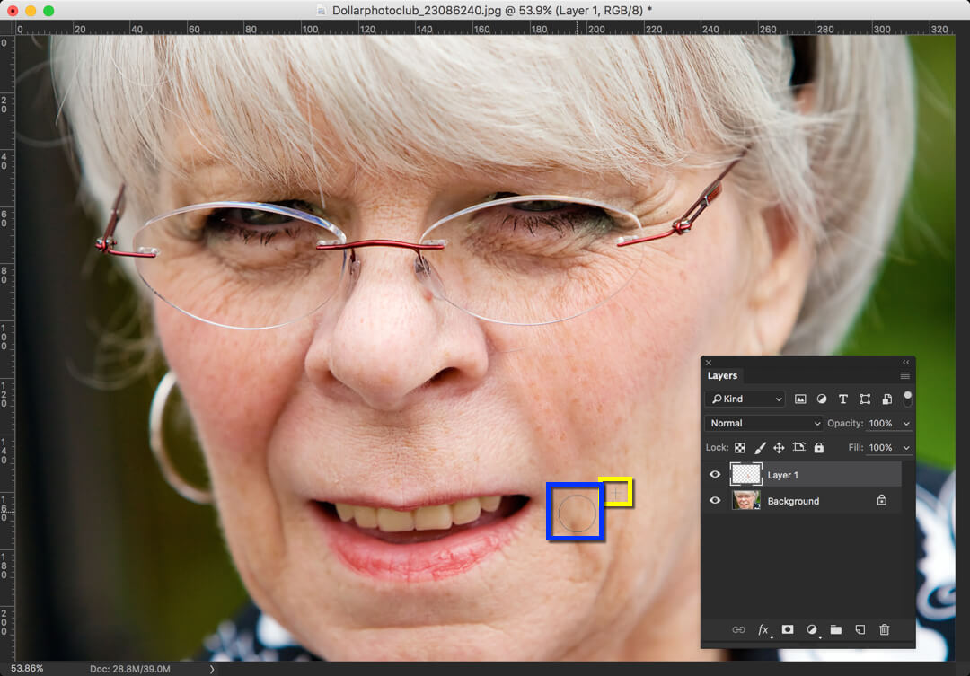
Photoshop calls the brush that is surrounded by:
- Blue color as “Target”
- Yellow color as “Source”

Step 4: Decrease The Opacity
Let’s decrease the opacity to 45% to keep this image looking natural.
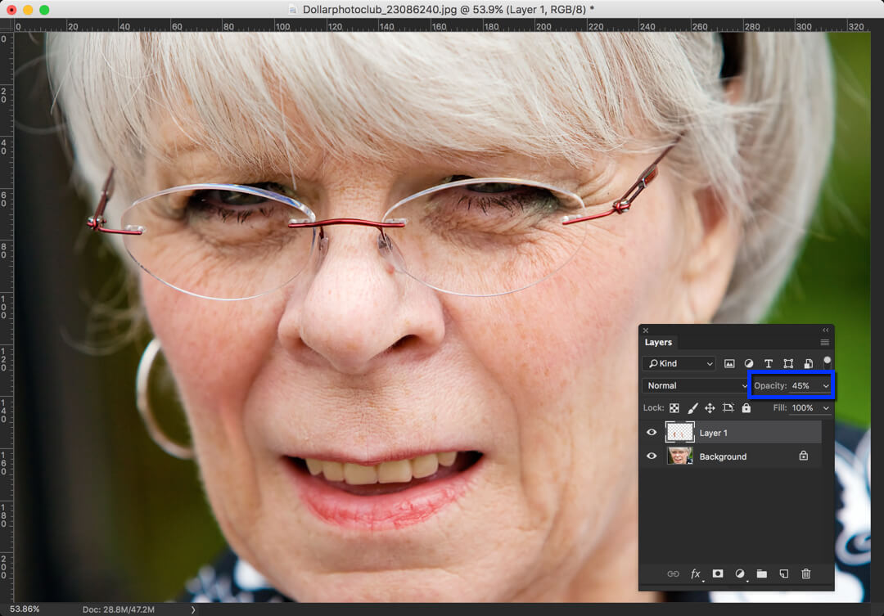

Option Bar Of Healing Brush Tool In Photoshop
As soon as you activate this tool, you might have noticed that the option bar has changed. To make this tool even more effective, we can make use of this option bar.

Let’s understand each tweak one by one.
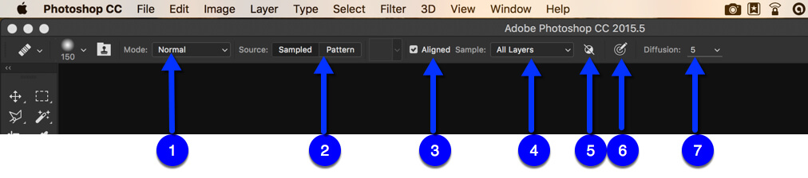
- Mode: This is something that we had already discussed in details on Blend Modes. This option lets you choose blend mode of the picture.
- Source: If we choose Sampled, Photoshop lets us choose the source that it can use as a reference to remove the flaw. This is what I chose the demo the above tutorial. If we choose Pattern, Photoshop will create a pattern to remove the flaw. In my opinion, it makes the image even more of flaw.
- Aligned: This is what I keep turned on most of the time. What this keeps is that it keeps the Source brush and Target brush aligned. In case you are having difficulty understand this feature, simply turn it off and try to use Healing brush tool.
- Sample: This lets you decide which layer to choose while taking your source as a reference. If you work non-destructively like me, it’s better to go with “All Layers”.
- Ignore Adjustments: If turned on, Photoshop will ignore adjustment layers when painting on your target. Generally, brightness, contrast, vibrance, etc. are called as adjustment layers. We’ll read more about it in later tutorials.
- Pressure: This is something you can use when you use pressure sensitive pads like Wacom tablets. If turned on, the harder you press, the harder your target gets brushed.
- Diffusion: Diffusion slider controls how quickly the pasted region adapts to the surrounding image. As a general guideline, low slider values are good for images with grains or fine details whereas high values are good for smooth images.

