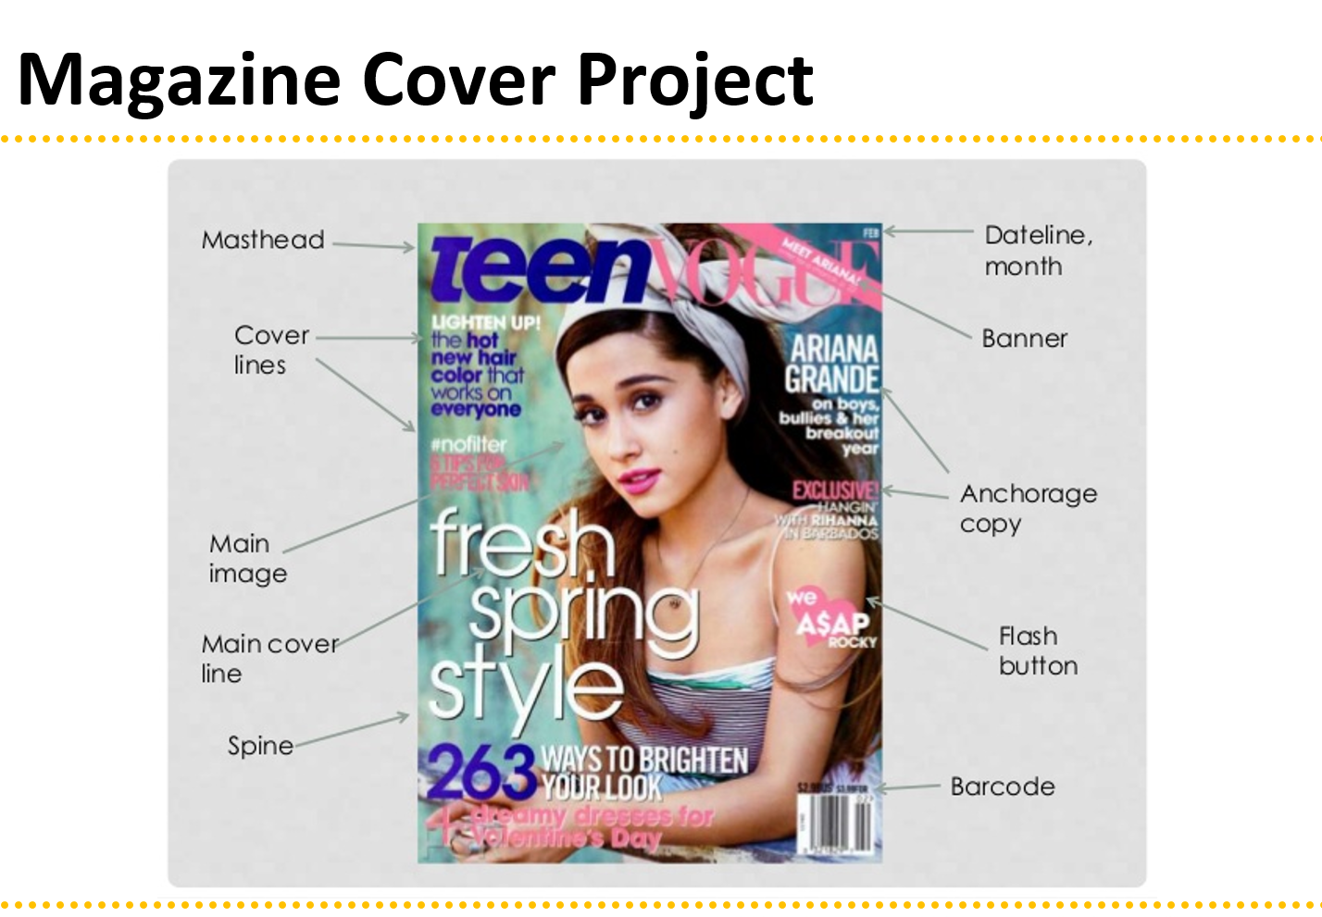
Project requirements:
• Name of magazine (largest letters)
• Headline related to the cover (smaller than name of magazine)
• At least 3 other article titles relating to stories inside (even smaller text)
- Titles may be (but don’t have to be) different sizes, fonts, colors (don’t get too carried away)
- May apply text effect (not required)
• Use fonts and colors that make it easy to read!
• At least one “See page # ……”
• Use an image or images (photo must be good quality)
- May use filters (consider a spotlight or lens flare on the main picture).
• Include the barcode, issue date, and cost.
• Don’t put any essential information too close to the edges (leave at least a quarter inch).
• Find a background that fits with your theme.
• Your Magazine Cover should be realistic.
• Your Magazine Cover must be free of grammar, punctuation, and spelling errors.
• Your Magazine Cover employs design elements, principles, typography, and color psychology.
• Include all the above parts of the magazine cover except Anchorage Copy.

Photoshop Directions:
- Make a Photoshop document that is 8 X 10.5 inches. (MAKE SURE it is set to inches, not pixels), and resolution 300. Name it Magazine Cover-your initials
- Place your image onto your document.
- Resize to fit where you need it.
- Replace the background if needed (you may use the internet to find your background).
- Use any filters or layer adjustments on your image that you deem appropriate for your theme. (You will likely need to rasterize your photo to do this.)
- Add your text to the document.
- Each item or text should be on its own layer.
- Make sure that your magazine title is big and bold and covers the width of the page.
- Use a readable font (or fonts) and choose colors that are easy to see.

Grading:
- Creativity:
  - You chose an interesting theme that no one else chose.
  - You tried some new methods and techniques not described above.
  - You thought through the idea thoroughly before starting.
- Craftsmanship:
  - There are no surface errors noticeable.
  - Colors and fonts are easy to red.
  - If image has been retouched, it has been done tastefully, not obnoxiously.
- Composition:
  - Image chosen has good composition (keep balance, rule of thirds, simplicity, avoiding mergers, and framing in mind).
- Requirements:
  - All requirements described in this handout have been implemented.

