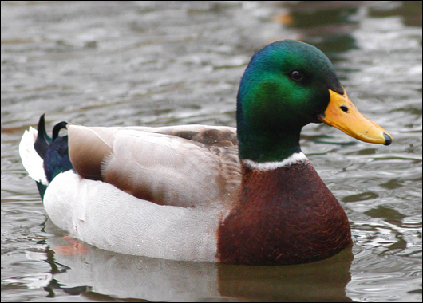

I am a duck. I have many animal adaptations to help me survive. I use my beak to spear fish and eat it with my sharp beak. I use my feet to swim and stay on top of the water. I use my wings to warn predators and to fly. My waterproof feathers are like insulation to keep my body warm and dry.