https://www.vyond.com/resources/what-is-a-storyboard-and-why-do-you-need-one/
Let’s dive in:
When you make a video for your business, be it an explainer video, marketing video, sales video, microlearning video, or any short online business video, planning is extremely important. One of the most important stages of planning out your video is creating a storyboard.

What is a Storyboard?
A storyboard is a graphic representation of how your video will unfold, shot by shot.
It’s made up of a number of squares with illustrations or pictures representing each shot, with notes about what’s going on in the scene and what’s being said in the script during that shot. Think of it as sort of a comic book version of your script.
A storyboard is your roadmap when you make a video.
Like a script, your storyboard visually guides you throughout the production process. By planning your video, you know which shots you need to create and how to create them when filming begins. You can get others’ feedback early on and make simple adjustments to your storyboard, rather than making major changes while filming.
To make a good storyboard, you don’t need to be a visual artist (though you can be). A storyboard can be anything from comic book-like rough sketches to stick figures to computer-generated drawings. To help you plan your own video, we’ll walk through the basics of creating storyboards, including:
- The basic elements of every storyboard
- A breakdown of two popular storyboarding methods
Understanding different ways to storyboard, you’ll be set to visually plan your own video. Regardless of your budget or design experience, you’ll be able to create a clear map that seamlessly guides you through production.

Why You Need a Storyboard?
Creating a storyboard might just sound like an extra step in the process of making a video for your business, but trust us — it’s a step you won’t want to ignore. Here are three reasons why you need a storyboard:

Best way to share your vision
A visual aid makes it much easier for you to share and explain your vision for your video with others.
We’ve all had experiences where we were trying to explain something and the other person just can’t see your vision. The core of this issue is that most stakeholders don’t have the experience of visualizing something off of a text deliverable, such as a script.
When you have a storyboard, you can show people exactly how your video is going to be mapped out and what it will look like. This makes it infinitely easier for other people to understand your idea.

Makes production much easier
When you storyboard a video you’re setting up a plan for production, including all the shots you’ll need, the order that they’ll be laid out, and how the visuals will interact with the script.
The video storyboard is a starting point or suggested thoroughline around which you can plan your coverage (all the angles you will shoot of a scene). This really comes in handy when you’re making your video, as it ensures you won’t forget any scenes and helps you piece together the video according to your vision.

Saves you time
While it may take you a little while to put your storyboard together, in the long run it will save you time in revisions later. Not only will it help you explain your vision to your team, but it will also make the creation process go more smoothly.

How to Create a Storyboard
Ultimately, a storyboard is a series of images representing each frame of your video. How you put the storyboard together, and how much detail you add, is up you — you can do it on paper, in a word processing program, or using specialized software.
Here’s how to go about creating a storyboard for your video:

1) Create blank slides
The first step in creating a storyboard is to draw a series of squares on a piece of paper
Here’s an example of a blank storyboard:
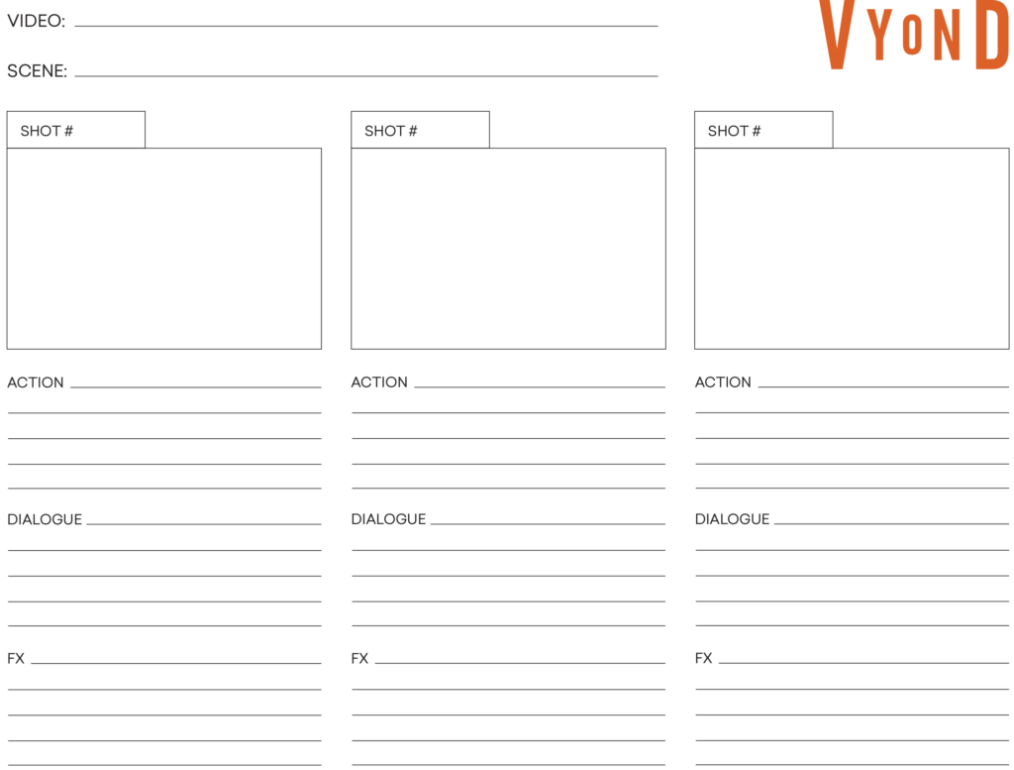
Don’t worry about your drawing skills — stick figures will suffice. Just make sure to leave room to jot down the accompanying text (whether it appears on the screen or is spoken by your characters or narrator) for each visual.
Creating a PowerPoint deck or simple word processing document on the computer is another easy option. Specialized software is also available if you’re looking for a more comprehensive solution (check out a few options below).
Think of these squares as the video frame. In each square a different shot or scene will take place. You can sketch the scenes by hand, create them on a computer or even take photographs. Make sure to leave space to write notes and lines from the script beneath or next to each frame.

2) Add your script
Beneath each picture, write the lines from the script that will be spoken in that scene and jot down some notes about what is happening.
Your storyboard should read like a comic book, so readers (coworkers, clients, etc.) can get a sense of exactly what will happen in your video.

3) Sketch your story
Next, you should sketch how each scene will look visually. Note that your storyboard doesn’t have to be incredibly detailed — you don’t have to draw in all of the props or even use color. (Hint: You don’t have to be great at drawing either. Bad drawings are far better than no drawings at all.)
Just provide enough visual detail to give an impression of what is happening, which characters are in the scene and what the general framing will look like. The script and notes will help fill in the rest of the details.
You can also make notes about camera angles and movement, transitions between shots and other details that will come in handy during production and post-production.
Whatever method you choose, be sure that your storyboard conveys what’s happening in the frame, the setting, which characters are present, any essential props, and what text (if any) will appear on screen and where. You can also include important notes about camera angles and movements, transitions between shots, and any other production or post-production details.
If you’re creating an extensive training program with multiple microlearning videos, consider completing the scripts and storyboards for each unit before beginning production on your videos. This will ensure that all the major topics you want to hit are covered, and that the videos fit together logically with minimal repetition.
As you storyboard, keep each video’s objective top of mind, and don’t be afraid to make revisions. This early stage of the process is the best time to tweak your visuals and script in order to create the most compelling and effective microlearning video possible.
Once your storyboard is approved, you’re finally ready to create a video!

Go-to Storyboard Checklist
Whether they’re drawn by a storyboard artist or diagrammed on a computer, all storyboards share the same information. They need to touch on the main actions, speech, and effects in every shot to clearly communicate how a video will appear.
Here are the key elements that every storyboard should include:
- Shot images: Individual panels featuring 2D drawings to show what’s happening—actions, characters—throughout a video
- Shot number: The number indicating when a shot appears according to a video’s shot list
- Action: The primary activity happening in a shot
- Dialogue (or narration: Any speech that is heard throughout a video
- FX: Technical details that explain how the shot is created in production and post-production (e.g. aspect ratio, camera angles, camera movement, shot type, sound effects, special effects)
A full storyboard has all of the information necessary to imagine how your finished video will appear. Reviewing your images and notes for each shot, you and your team can brainstorm how your video should be adjusted and what resources you will need in production.

Popular Storyboarding Methods
When most people hear the word “storyboard,” they think of a professional animator quickly sketching out a cartoon feature film.
As it turns out, a storyboard doesn’t have to be a work of art—it doesn’t even have to be hand-drawn. With video production software, there are options for all types of users—regardless of their industry, design experience, or budget—to create useful professional-grade storyboards.

Hand-drawn storyboards
The classic storyboarding process is drawing by hand. You sketch out a mock-up of what each shot will look like.
As mentioned, you don’t need to be a great artist to create a storyboard—stick figures are enough. The principal goal is to convey the main action that is happening in the shot, so each frame doesn’t need to be very detailed.
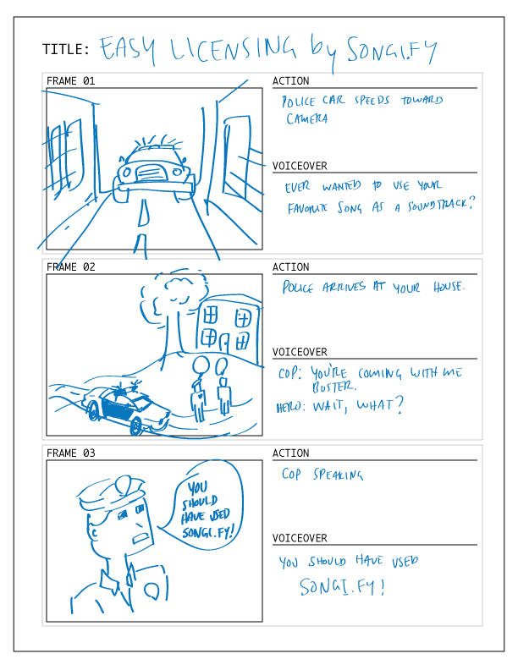
A longhand storyboard cuts costs, but it’s not necessarily the most efficient option, as seen in these pros and cons:
- Pro: It’s free. All you need is a pencil and paper to create a hand-drawn storyboard.
- Con: It’s time-consuming. Drawing every single shot—even if they’re not detailed—will take a while considering that one storyboard frame only represents six seconds of a video. For a three-minute video, for example, you would need 30 storyboard frames. There is also a risk of losing your storyboard since your work is tied to a piece of paper.
If you hope to keep video costs low, a hand-drawn storyboard is probably the best method for you. Just keep in mind that you will need to devote at least a few hours, if not more, to complete the task, and you’ll need to scan or make copies of your storyboard for everyone working on your video.

Helpful Storyboarding Tips
Here are some tips that can help you as you storyboard your video:
- Show, don’t tell. Use the storyboard as a litmus test to determine if your story is truly being visualized.
- Be cinematic. Does your video do things that movies do? Do people, places and things move or stand still? Does the camera move? Keep these factors in mind and bring them all together to create a cinematic video.
- Make sure it’s logical and coherent. You’re creating a story, so the video should look visually consistent from beginning to end
- Pick a theme. If you want to create a video infographic, add relevant charts and graphs. Want to highlight a customer pain point, show a character on screen and take them through a journey.
Here’s a great example of a story-based video that was planned to perfection:
https://youtu.be/mK5K-o56nMU

