Public Service Announcement
Definition:
A public service announcement (PSA) or public service ad is a type of advertisement featured on television, radio, print or other media. Whereas the objective of a standard advertisement is to market a product, a PSA is intended to benefit the public interest, by raising awareness of an issue, affecting public attitudes, and potentially stimulating action. Radio and TV stations are required to offer time on their stations for running PSAs. They can be run on behalf of community events, charity events, non-profit organizations, etc.
CHARACTERISTICS:

The most common topics of PSAs are health and safety. A typical PSA is part of a public awareness campaign to inform or educate the public about an issue such as obesity or compulsive gambling. The range of possible topics has expanded over time and includes: encouraging people to adopt animals rather than buy them and to go “green.” PSAs are sponsored by non-profit or private organizations and may enlist the support of a celebrity for a PSA.

What makes a good 30 second PSA?
A good 30 second PSA contains all the key messages and information laid out in a pleasing, yet succinct manner. The challenge is doing it in under 90 words. You’ll need a strong hook at the opening and a compelling call to action at the end.
For example, this is a 30 second PSA script on vaccinations from the Illinois State Medical Society:
In healthcare, misinformation can be as deadly as the most serious disease – and spread just as quickly. For years now, myths about childhood immunizations have been spreading on the Internet and social media. The physicians of the Illinois State Medical Society urge parents to know the facts and get your children immunized. Immunizations are scientifically proven to be safe and effective, and failure to immunize can harm your children and others. Talk to your child’s doctor to get the facts about immunizations.
Look at the first sentence – a very strong hook. It gets people’s attention. Next there’s the key messages of the PSA that provides the information the organization wanted to convey about vaccinations. Finally, it ends with a compelling call to action, for parents to talk to their children’s doctor about immunizations.
This next 30 second PSA example from the Leukemia Research Foundation announces an upcoming conference, encouraging people to attend:
If you or a loved one is living with leukemia, lymphoma, multiple myeloma, or MDS, don’t miss the 15th annual Treatment Options for Blood Cancer Patients conference on Saturday morning, May 11, at the Hyatt Regency in Lisle. You’ll learn about the latest breakthroughs and emerging treatments presented by leading experts in the field. The free Treatment Options Conference is presented by the Leukemia Research Foundation and includes breakfast and lunch. For more information, registration, and a full program agenda visit all-blood-cancers-dot-org.
In addition to including details of what will happen at the conference, this PSA also includes the day, date, time, and location of the event as well as a website that offers even more information.

How to write a 30 second PSA
The first step in writing a PSA is drilling down to your key messages. Chances are you already know the topic, be it an upcoming event or a planned awareness campaign. If the PSA is meant to create awareness for your organization and the community benefit it provides, then you may need to focus on a single topic.
Know your audience before you begin writing. You want to tailor your PSA to your targeted demographic. For instance, your approach to reaching young married couples will likely be different than retirees.
Always start with a strong hook, something to get your audience’s attention and keep them listening.
Avoid broad strokes. You want your focus to be narrow so the message stays clear and sharp.
Adding statistics and citing expert resources makes your PSA stronger. Make sure that any information you include is the most current available. Accuracy is vital. Outdated or wrong information can damage your organization’s credibility.
Create the script, keeping in mind the maximum word count of 90. It may help to first bullet point and order the information that you’d like to include. Put the most important information at the top of the list, and work from there. Around 5 to 7 key aspects tend to work best but keep them concise.
Once your script is complete, record it and distribute it to the key stations in your targeted area.

Crucial information to include in your PSA (a checklist)
Use this helpful checklist when you sit down to write your 30 second PSA.
- Write your script to a total of no more than 90 words (could be as few as 75 words). A professional voice talent can speak about 180 words a minute at a moderate pace. This means that in 30 seconds they can speak about 90 words.
- Develop a strong hook that grabs the listener’s attention and holds it while the key messages are conveyed.
- Prepare 5 to 7 main points that support a single message.
- Include facts or statistics with resources to back it up.
- If it’s an event, provide the day, date, time, location, and cost
- Close with a compelling call to action telling listeners to “call this number,” “talk to your doctor,” “visit this website,” or “attend the event.”
STEP 1 – The Overall Message
- The most important part of your PSA is your message.
- Make your message as clear as possible using simple descriptive words:
“Help us deliver quality clean air for generations to come.”
STEP 2 – The OPENING HOOK
- Decide how you will grab the attention of your audience.
  - Emulation
    - Suggests characteristics in people that you might want to imitate.
“The best leaders never let failure deter them from achieving their goals.”
  - Bandwagon
    - Suggests that “everyone is doing it” so you should do it, too. This is an appeal suggesting that you should go along with the crowd.
“Don’t be the last one to receive the benefits of Cycle Health’s natural remedy for better living.”

  - Injustice
    - Attempts to shed light on bad or poor conditions and tries to arouse people to act in response.
“Every year the polar bear loses more and more of its natural habitat, and we are running out of time to act.”
  - Status
    - Suggests that if you act or look a certain way, you will gain importance or status.
“If you want to really stand out in a crowd then be sure to visit Dr. Watson for your free teeth whitening.”
  - Altruism
    - Suggests a regard for the interests of others. The altruistic appeal suggests that you will be rewarded if you do good for others.
“There is no better feeling than helping the needy children supported by Children Help International.”
  - Pleasure
    - Suggests that if you do a certain thing or go to a certain place, you will have fun or experience joy.
“The best way to have fun this summer is to get a membership at The Wild Wacky Water Park.”
  - Stats
    - Provide statistics that are related to your issue.
“Four out of five doctors recommend mint toothpaste over cinnamon in order to fight bad breath.”
  - Questions
    - Mission Statement
      - Make a brief point about the goals of your organization.
“The Friendly Help Clinic prides itself on quick, efficient and reliable public service.”
  - Mission Statement
    - Make a brief point about the goals of your organization.
“The Friendly Help Clinic prides itself on quick, efficient and reliable public service.”
  - Emotion
    - Explain the benefits of getting involved for both the audience and those in need by using emotional language.
“Your contribution to the disaster relief will help those affected by the hurricane.”

STEP 3 – The INFORMATIONAL ELEMENTS
- Choose which informational elements you will include to advertise your message.
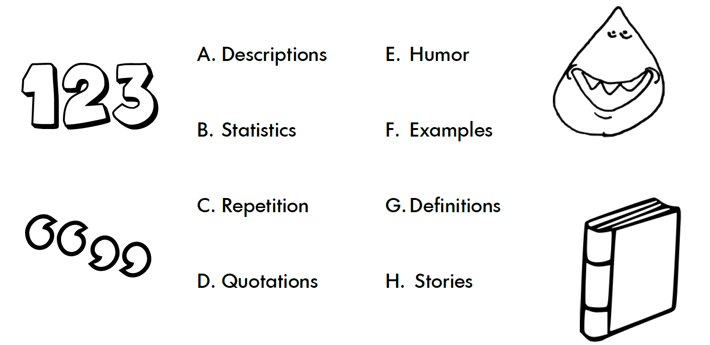

STEP 4 – The Key Information
- Provide the specific details about what the listeners need to know.
- It helps if you think about the details in terms of when/where and why.
  - When/Where
“This Saturday in Byers Square in front of City Hall.”
  - Why
“You should come on down and support the cause to fight deforestation.”
STEP 5 – The call to action
- Let the audience know how they can get involved, donate money or support the cause in other ways like volunteering.
- Provide clear direction on what your audience is to do after they hear your announcement.
STEP 6 – The contact information
- Provide a telephone number, website, email address, etc.
- Usually you put this at the end of the announcement.

STEP 7 – The timing
- Keep in mind that the amount of time you have to give your announcement is limited.
- The amount of time that you have can range from 10 seconds to 60 seconds.
- Plan your script so that it fits into your time allotment.
Length of  PSA | 10 seconds | 15 seconds | 30 seconds | 60 seconds
Number of Words | 20-25 | 30-35 | 60-75 | 120-140
What you can/can’t include in a PSA:
Can’t | Can
“Donate” | Ask for “help”
“Give” | Ask viewers to “join” us
“Money” | Encourage viewers to go to a website “for more information”.
“Support” | General use of “support” (like “find our how you can support your neighbor…”
Any direct language about giving $
Mention a corporate partner/display logo

PSA EXAMPLES:
PSA Example 1
Time: 10 seconds
Organization: Water Conservation Authority
Title: “Water Wednesdays”
The Water Conservation Authority wishes to announce that starting this June, Water Wednesdays will begin. For more information please call 555-5555. Thank you.
PSA Example 2
Time: 30 seconds
Organization: Readers Choice
Title: “Reading”
Research shows that success in school and life starts with literacy. When children become good readers early in their education, they are more likely to become better learners throughout their school years and beyond. In a nationwide effort to communicate to parents the importance of reading to their school-aged children, Readers Choice is teaming up with the National Livrarians to promote the nationwide campaign, “Young Readers.” Help us make September “Reading Awareness Month” by visiting www.youngreaders.com
PSA Example 3
Time: 30 seconds
Organization: American Library Association
Title: “National Library Week”
Community-building connectons are happening all the time at your library. From new moms connecting at storytime to small business owners convening at storytime to small business owners convening to make opportunities happen, to teens meeting up after school, the library helps foster all types of communities. April 14-20 is National Library Week. Visit your library. Communities matter @ your library.
A message from the American Library Association’s Campaign for America’s Libraries and the White Lake Library.
PSA Example 4
Time: 30 seconds
Organization: American Library Association
Title: “Library Card Sign Up Week”
My library card is the smartest card in my wallet! September is Library Card Sign-up Month! The library is a community hub of activity. In tough economic times, your library card gives you free access to books and computers, homework help, assistance with resumes and job searches, accurate financial information, adult education courses, music, movies, and much more! Go to your library and get your library card today!

Assignment:
  - pick a psa topic from the list below:
Health/Safety Awareness | School Awareness | Environment | Community/World Awareness
- Anti-Smoking  - Exercising  - Nutrition  - Dangers of Vaping  - Distracted Driving | - Learning to Read  - Stay in School/Graduate  - Good Citizenship  - Doing Your Homework | - Water Conservation  - Energy Conservation  - Alternative Energy  - Global Warming  - Littering | - Anti-bullying  - Anti-Cyberbullying
  - Research information pertaining to topic.
    - Be sure to include important facts or statistics.
  - Create a storyboard.
    - Include sketches of each scene and a written script.
    - Include a work cited page to record the sources used.
  - Create a video PSA using Adobe Premiere pro.
    - Save the video as a Premiere Pro video and export as an mp4. Save in your PSA folder in our class folder.

