Advanced Computer Applications
Podcast Groups
Group 1 – Nikki, Riann, Devin, Gunner
Group 2 – Anna, Emily, Austin
Group 3 – Whitney, Devon, Seth, Courtney

As a group, you will need to decide who will be your host and who is doing each segment. You will individually write your segments and then copy and paste them into one final script of the entire podcast with everyone’s segments included. The script will also need the names of the bumper, intro, and closing music that you plan to use. The host will not have to do a segment, but should write interesting introductions for each segment after the segments are all placed in the script. If you are in a group of three, your podcast should be 6-7 minutes in length. If you are in a group of four, your podcast should be 7-8 minutes in length. Below you will find a list of required segments, but you may add segments to complete your required time. Some of you may need to do two or more segments. All segments must have something to do with voting or other rights of American Citizens, Veterans or Veterans Day, or other Patriotic topics. Try to aim for 60-second segments or longer (at least for the required segments). The additional segments may be shorter, but no shorter than 30 seconds.
Required Segments:
- What is Veterans Day? What did it used to be called? When did we start celebrating Veteran’s Day? Why do we celebrate Veterans Day? (any other information that you want to add.)
- American citizens’ right (civic duty) to vote – Why should we vote? Who can vote? When do we vote for President? How often? Is it the duty of the American citizen to study the issues and vote responsibly, or is it good enough to just show up and vote? Is voting a right or a privilege? Can all citizens vote?
- What does it take to become a US citizen?
- Rights, duties, and responsibilities of a US citizen 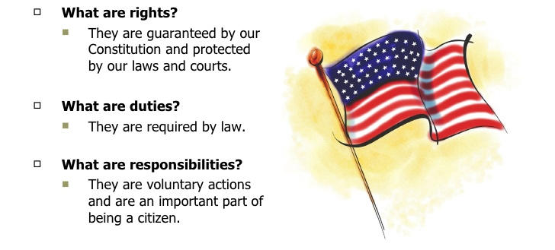

Bumper Music
Host: Hello from White Lake, South Dakota, home of Purple Pride Radio! This podcast features information about the American citizen’s right to vote. We will also be discussing those who have fought for that right in our segment on Veteran’s Day. I’m __________________ and I’ll be your host as we learn about our right to vote in America and honoring those who fought for that right.
Bumper Music
Host: Let’s hear from __________________ and hear what he/she has to tell us.
Bumper Music
First Segment: Thanks [name of host]! ………………………………………………………………………………………………
------------------------------------------------------------------------------------------------------------------------------------
That’s it for me! Thanks for listening! Now back to our host!
Bumper Music
Host: Thank first segment and introduce second segment.
Second Segment: -----------------------------------------
---------------------------------------
--------------------------------------
I hope you enjoyed my segment on ________. Thanks for listening. Now back to our host.
Bumper Music
Third Segment: Thanks [name of host]! ………………………………………………………………………………………………
------------------------------------------------------------------------------------------------------------------------------------
Bumper Music
Host: It is time for our podcast to end. I hope you have enjoyed listening and have learned some new and interesting information about _________. Thank you for listening to our podcast on Purple Pride Radio.
Closing Music

