The Different Extensions & When to Use Them

JPEG (or JPG) - Joint Photographic Experts Group
JPEGs might be the most common file type you run across on the web, and more than likely the kind of image that is in your company's MS Word version of its letterhead. JPEGs are known for their “lossy” compression, meaning that the quality of the image decreases as the file size decreases.
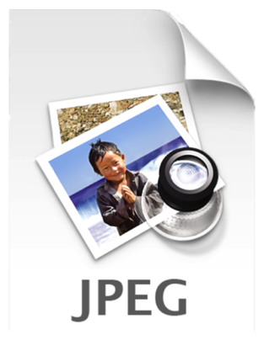
You can use JPEGs for projects on the web, in Microsoft Office documents, or for projects that require printing at a high resolution. Paying attention to the resolution and file size with JPEGs is essential in order to produce a nice looking project.

PNG – Portable Network Graphics
PNGs are amazing for interactive documents such as web pages, but are not suitable for print. While PNGs are "lossless", meaning you can edit them and not lose quality, they are still low resolution.
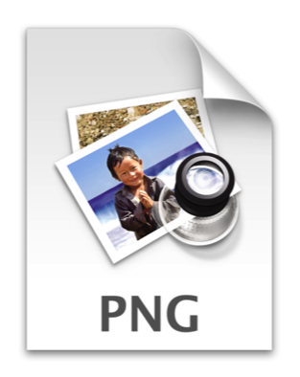
The reason PNGs are used in most web projects is that you can save your image with more colors on a transparent background. This makes for a much sharper, web-quality image.

GIF – Graphics Interchange Format
GIFs are most common in their animated form, which are all the rage on Tumblr pages and in banner ads. It seems like every other day we have a new Grumpy Cat or Honey Boo Booanimated GIF. In their more basic form, GIFs are formed from up to 256 colors in the RGB colorspace. Due to the limited number of colors, the file size is drastically reduced.
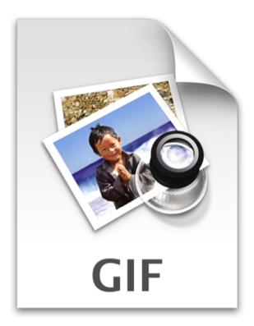
This is a common file type for web projects where an image needs to load very quickly, as opposed to one that needs to retain a higher level of quality.

TIF – Tagged Image File
A TIF is a large raster file that doesn’t lose quality; it is usually used when saving photographs for print. Don’t use this file on the web; it will take forever to load!
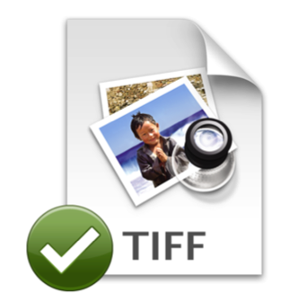

PSD – Photoshop Document
PSDs are files that are created and saved in Adobe Photoshop, the most popular graphics editing software ever! This type of file contains “layers” that make modifying the image much easier to handle. This is also the program that generates the raster file types mentioned above.
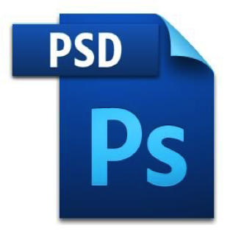
The largest disadvantage to PSDs is that Photoshop works with raster images as opposed to vector images.

PDF – Portable Document Format
PDFs were invented by Adobe with the goal of capturing and reviewing rich information from any application, on any computer, with anyone, anywhere. I’d say they have been pretty successful so far. If a designer saves your vector logo in PDF format, then you can view it without any design editing software (as long as you have downloaded the free Acrobat Reader software) and they have the ability to use this file to make further manipulations. This is by far the best universal tool for sharing graphics.
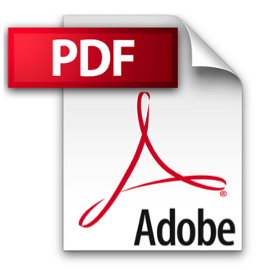

EPS – Encapsulated Postscript
EPS is a file in vector format that has been designed to produce high-resolution graphics for print. Almost any kind of design software can create an EPS. It is more of a universal file type (much like the PDF) that can be used to open vector-based artwork in any design editor, not just the more common Adobe products. This safeguards file transfers to designers that are not yet utilizing Adobe products, but may be using Corel Draw or Quark.
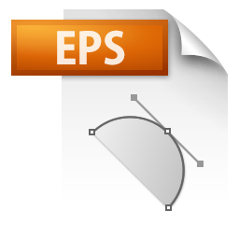

AI – Adobe Illustrator Document
AI is, by far, the image format most preferred by designers and the most reliable type of file format for using images in all types of projects from web to print, etc. Adobe Illustrator is the industry standard for creating artwork from scratch and therefore more than likely the program in which your logo was originally rendered. Illustrator produces vector artwork, the easiest type of file to manipulate. It can also create all of the aforementioned file types. Pretty cool stuff! It is by far the best tool in any designer’s arsenal.
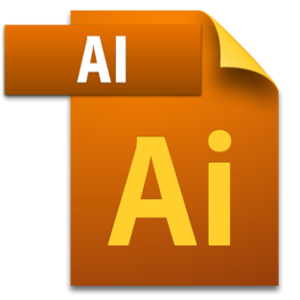

INDD – Adobe Indesign Document
INDDs (Indesign Document) are files that are created and saved in Adobe Indesign. Indesign is commonly used to create larger publications, such as newspapers, magazines and eBooks.
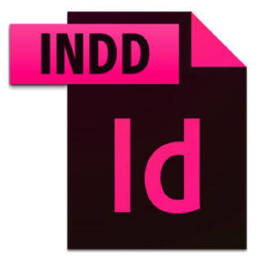
Files from both Adobe Photoshop and Illustrator can be combined in Indesign to produce content rich designs that feature advanced typography, embedded graphics, page content, formatting information and other sophisticated layout-related options.
Working with images is a lot more complicated than at first glance. Hopefully this guide has provided a better understanding of the standard file types and which are most appropriate for your project. Maybe this article has you wondering which file types of your logo you have on hand? Take a look and if you don’t have an .EPS or .AI file stashed away, I would recommend contacting your designer!
As Art Director at Quintain Marketing, Jessie-Lee brings a unique blend of graphic design skills and marketing and social media knowledge. In addition to her design skills, Jessie-Lee has extensive experience in the design and implementation of social media strategies including blogging, and the use of platforms such as Facebook, Twitter and LinkedIn.

