Multimedia
Bell Ringer – Boggle on the white board
1. In your journal notebook, go to the back cover and fill out the entry #4.
Expectations – Find at least 15 words with at least 2 letters.
Description – Boggle
Strategy – L
2. Then go to your first available notebook page (remember to use both sides of the paper)
and write Boggle and the date (8/28/18) on the top line.
3. The substitute teacher will time you for 5 minutes. Stop when the time is up and one of
your classmates will pick up the notebooks and turn them in.
Assignment – Go to the website https://www.cartoonify.de/ and scroll until you see what is pictured below.
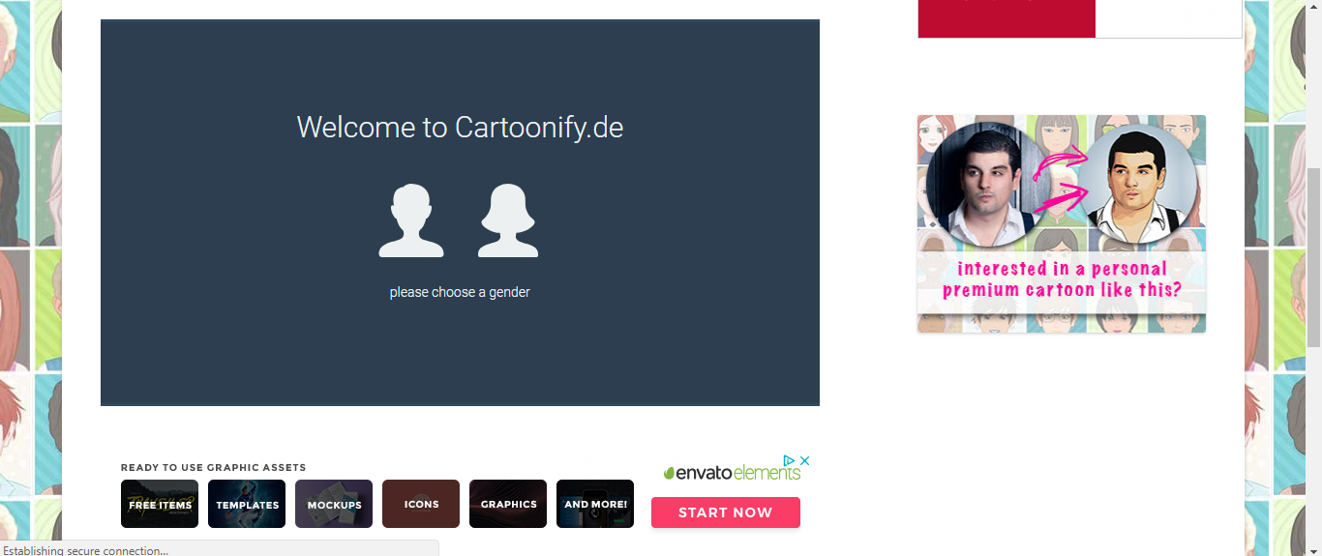
Click on your gender.
Try to make your character look like you.
- Choose your skin color and face shape.

- Click on the Eyes tab and choose eye shape and color.
You may continue editing the eyes by choosing options on the iris, eyebrows, and glasses tabs.
Remember that you want your character to look like you.
- Click on the Hair tab and choose hairstyle and color.
- Click on Clothes tab and choose your option for clothes and colors.
- Click on the Backs tab to choose your background and color.
- Click Download and choose 600X600 png
- It should show up at the bottom of your screen.
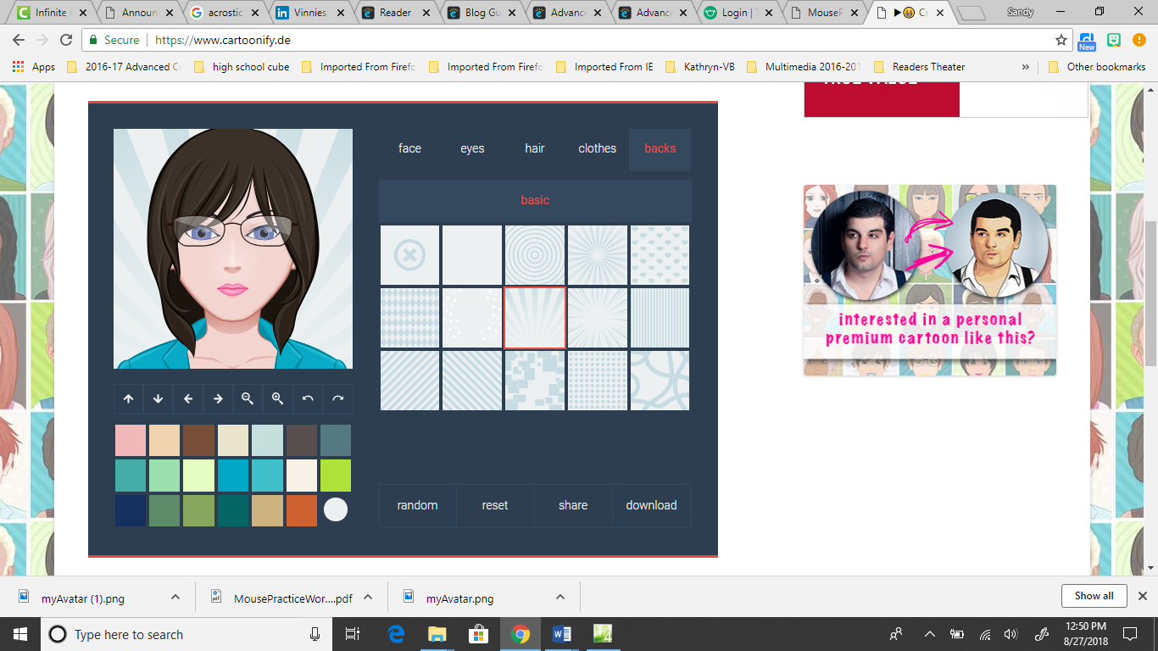

- Click the arrow beside the image and choose Show in Folder.
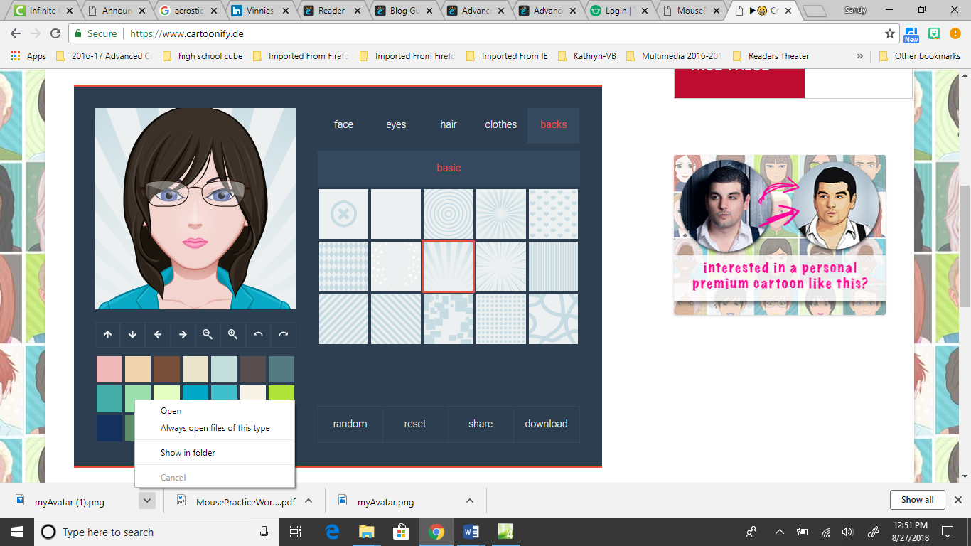

- Your download folder should open up with your avatar selected. Right-click on it and choose copy.
- Go to our class folder on the Share Drive and go into the folder with your name on it. Make a new folder called Pictures and paste the avatar inside.
Use this path (breadcrumb trail, but your folder instead of mine.)

- Now log onto your edublog site and get into the dashboard.

- In the navigation pane on the left, click on Users and choose Your Avatar.

- Click on Choose File and navigate to find it where you saved it. Click on the avatar image and click Open. Then Click Upload.
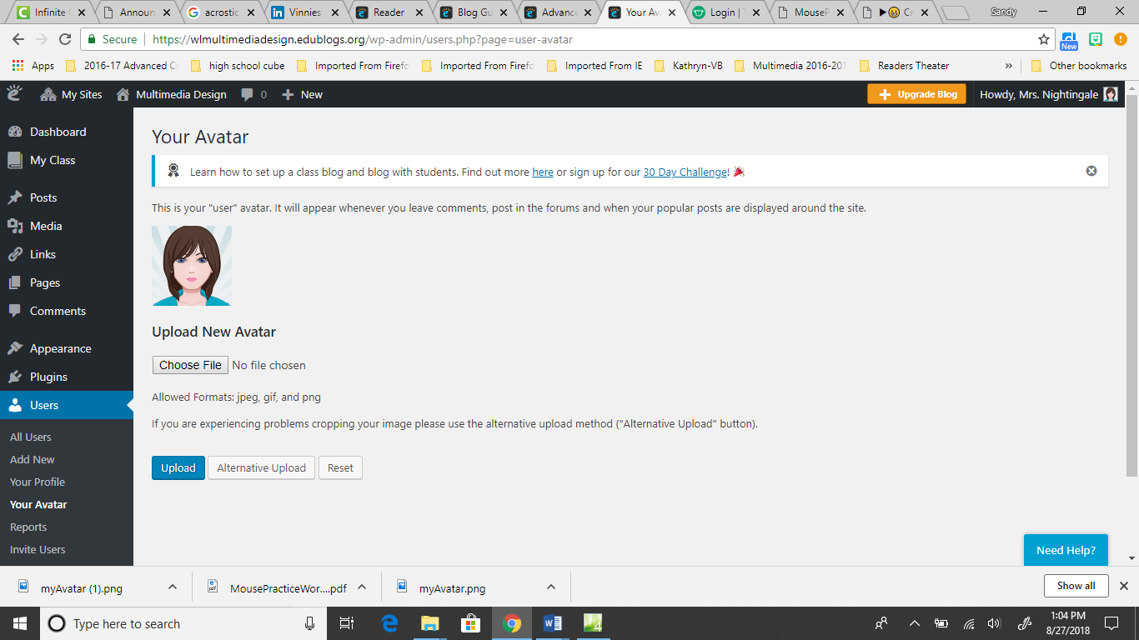

- Drag the cropping handles around the image.
Click on Crop Image.

That completes the User Avatar.
- Then on the Dashboard, in the navigation pane, click on Settings and choose Blog Avatar.
- Repeat steps 13-14 to upload and crop your Blog Avatar.

- If you did all the steps correctly, you should see your avatar in two places when you visit your actual site.
Here

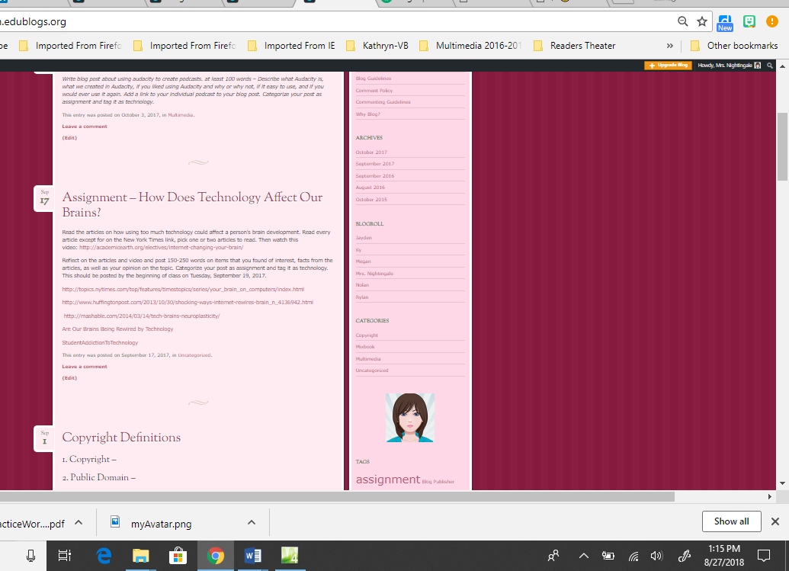

And Here

This is due by the beginning of class on Wednesday (tomorrow).

