Infographics
Since infographics exploded onto the graphic design scene about ten years ago, they’ve become a staple for communication in classrooms, in the workplace, and across the web.
But if you’re new to the world of design, the term infographic might still be foreign to you.

You might wonder…

What is an infographic? Infographics defined:
According to the Oxford English Dictionary, an infographic (or information graphic) is “a visual representation of information or data”.
But the meaning of an infographic is something much more specific.
An infographic is a collection of imagery, charts, and minimal text that gives an easy-to-understand overview of a topic.
As in the example on the next page, infographics use striking, engaging visuals to communicate information quickly and clearly.

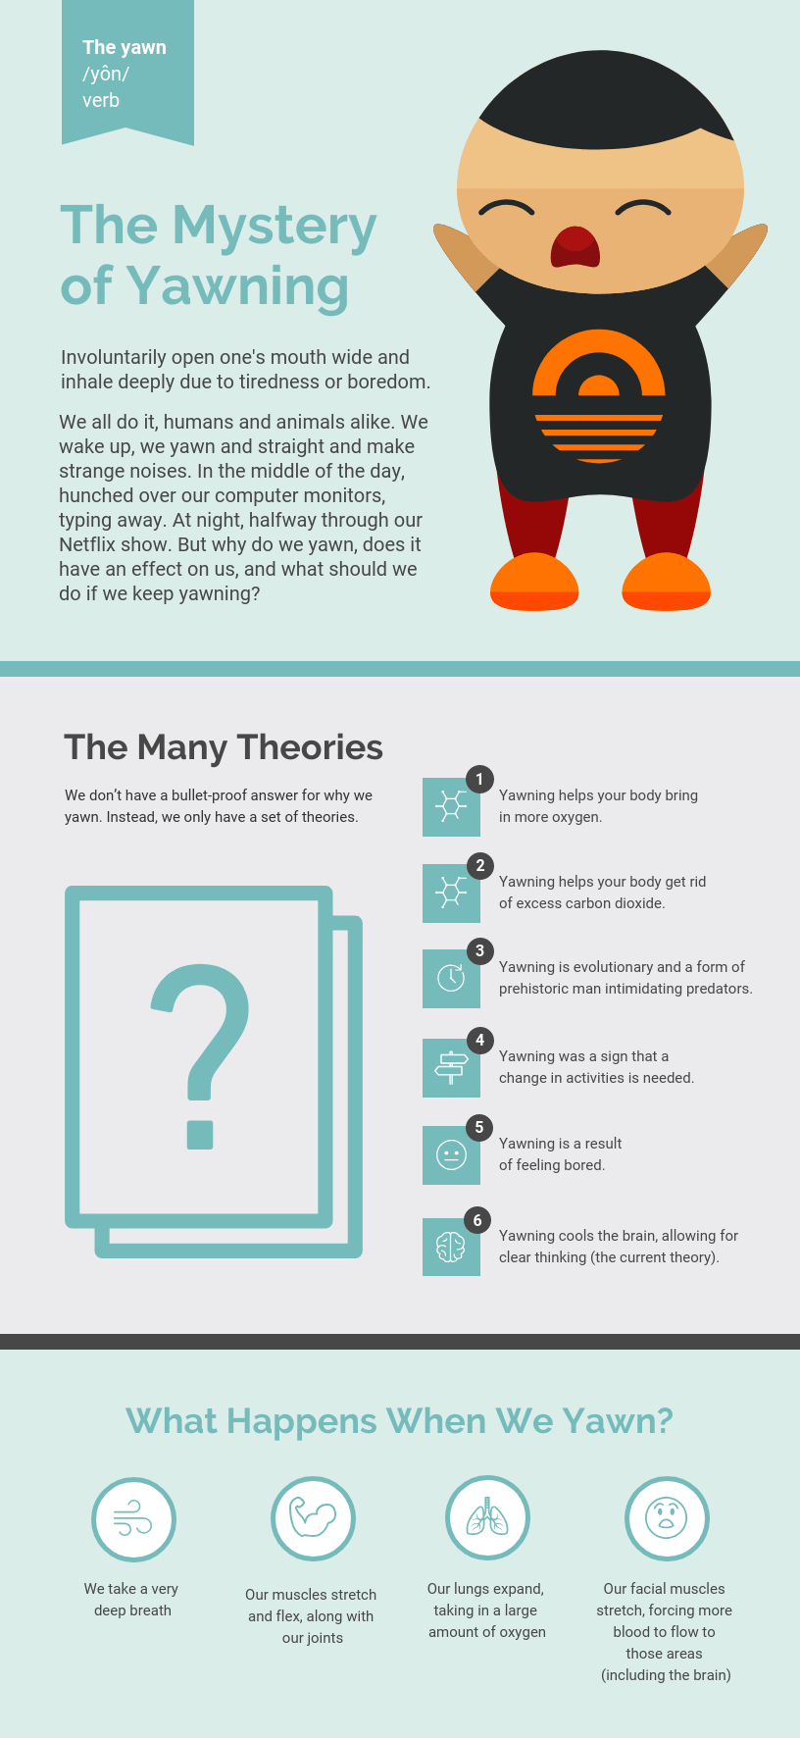
Infographic
Your assignment is to go to canva.com and make an account with your school email so you can save your creations. Create an educational design to create an infographic on Silent movies. You may use the information that you wrote in your essay, but you must also include pictures. Save your infographic in Canvas and also download the finished infographic to your computer. Submit the downloaded PDF to Google Classroom by the beginning of Friday’s class. Here is an example:
