You Are What You Eat!
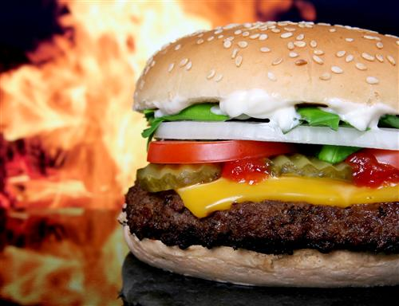

What should we eat? How much should we eat? How do we know if we're really eating a nutritious meal? We all want to eat healthy food, but when we eat at restaurants, sometimes it's difficult to know if we're really eating a meal that's good for us. Luckily, many restaurants post the nutritional information for their menu selections on their websites. This allows consumers to visit the website before they visit the restaurant, so they can make healthy choices!
On average, a healthy child needs between 1,600 and 2,500 calories each day. Create two menus for yourself: one order "without thinking" and the other order that is "mindful eating'. Compare the two orders in an Excel pie chart.
Burger King
Wendy's
McDonald's
Chick-Fil-A
Taco Bell
Five Guys
Red Robin
Starbucks
Chipotle

