Step 1 - Creating Tables
- Start Word and Open a new document.
- Click the Insert tab > Table button
- A grid opens below the button.
- You move the pointer across the grid to select the number of columns and rows you want the table to contain.
- Point to the second box in the fourth row to select 2 x 4 Table, the click
A table with with two columns and four rows is inserted in the document, as shown in Figure E-1.
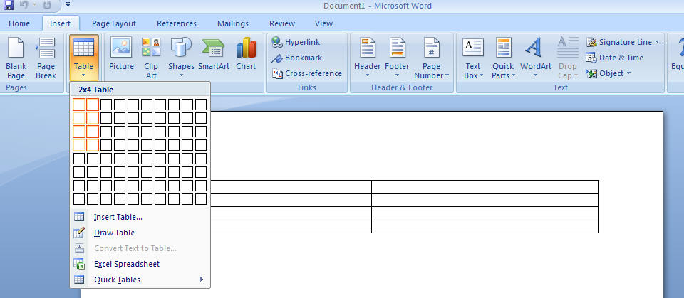
- Tables are made up of Rows and columns. Below is a picture illustrating a ROW.
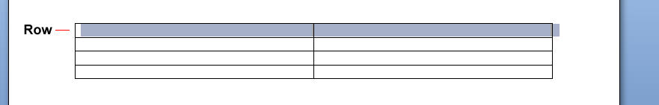
- Below is a picture illustrating a COLUMN.
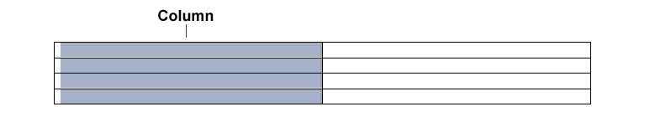

- Below is a picture of a Cell - A cell is the single box where a row and a column intersect.
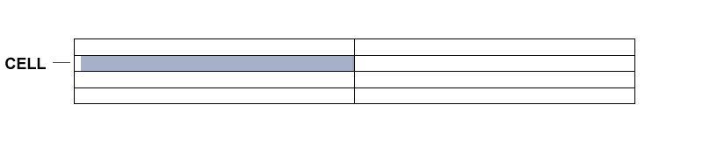
- In the first cell (top-left cell) Type Location, then press [Tab]
Pressing [Tab] move the insertion point to the next cell in the row.
- Type Cost, press [Tab], then type the name of your favorite Breakfast Restaurant
Pressing [Tab] at the end of a row moves the insertion point to the first cell in the next row.
- Press [Tab], type dollar amount that your favorite meal might cost there
- Press [Tab], then type the name of your favorite lunch place and the cost of the average lunch meal there, pressing [Tab] to move from cell to cell
- In the fourth row input your favorite Dinner place and the average cost of that meal.
- Press [Tab]
Pressing [Tab] at the end of the last cell of a table creates a new row at the bottom of the table, as shown in Figure E-2. The insertion point is located in the first cell in the new row.
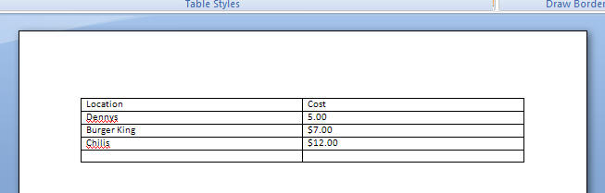
- Type the following, pressing [Tab] to move from cell to cell and to create new rows
One more Breakfast place and cost
Two more Lunch places and costs
One more dinner place and costs
- Click the Save button on the Standard toolbar, then save the document with the filename Boston Ad Budget to the drive and folder where your Project Files are located
The table is shown in Figure E-3
