Step 1 - Creating AutoShapes
- Open Microsoft Word and make sure that there is a blank document on your screen.
- Save this new document as Genre Sales to the drive and folder where your Project Files are located.
- This lesson is focusing on the Drawing Tools. Check out the video to see some of the basics that will be covered.
- Click the Insert tab > Shapes > Rectangle button from the drop down list
When you click an AutoShape button, the pointer changes to +.
- On your blank document, drag down and to the right to create a rectangle that is about 5" wide and ½" tall
You do not need to be exact in your measurements as you drag.
- Once this rectangle has been created, you should notice the Drawing Tools tab at the top of the screen. This whole lesson will focus on this tool.
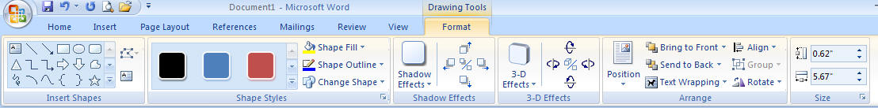
- With your rectangle still selected, locate the Insert Shapes section of the Drawing Tools
- Scroll down to locate the sun that is in the Basic Shapes section, then click the Sun
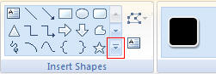
- Place the + pointer just above the rectangle and drag down and to the right to create a sun that is about ½" wide
The sun shape includes a yellow diamond-shaped adjustment handle. You can drag an adjustment handle to change the shape, but not the size, of many AutoShapes
- Position the pointer over the adjustment handle (the little yellow diamond inside the sun)until it changes into a pointer, drag the handle to the right about ¼", click the Fill Color list arrow on the Drawing toolbar, click Gold, click the rectangle to select it, click , then click Aqua
The sun shape becomes narrower and the shapes are filled with color. Notice that when you select a color, the active color changes on the Fill Color button.
- Draw three more rectangles, click to turn off the tool, then fill the rectangles with color
- After all four rectangles are drawn, use the sizing handles to resize the rectangles if necessary.
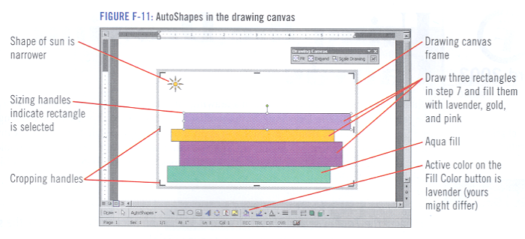
- Press and hold [Shift], click each rectangle to select it, click the 3-D Style button 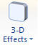on the Drawing toolbar, then click 3-D Style 1
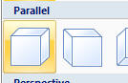
- The rectangles become three-dimensional, making the group look like a stack of books.
- Deselect the books, right-click the top book, click Add Text, click the Font Size list arrow on the Home Tab, click 20, then type Children's - 17%
The 3-D rectangle changes to a text box. You can convert any shape to a text box by right-clicking it and clicking Add Text.
- Add the 20-point text as shown in Figure F-12, then save your changes.
