Step 1 - Adding Graphics
- Right-click and select Save Target as... on this link... Right-Click here to get the file
- Save this file as Ad Tips to your directory
- Open Microsoft Word and Open that Ad Tips file.
- Click the View tab, click Page Width if necessary, then read the document to get a feel for its contents.
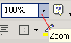
The document opens in Print Layout View
- Click before the heading "Create a simple layout" (It is located near the top of the page), you will insert a picture file
Save this file to your directory. Click here to get the file
- Click Insert > Picture
The Insert Picture dialog box opens. You use this dialog box to locate and insert graphic files. Most graphic files are bitmap graphics, which are composed of a series of small dots, called pixels, that define color and intensity. Bitmap graphics are often saved with a .bmp, .png, .jpg, .wmf, .tif, or .gif file extension. Use the Files of type list arrow in the Insert Picture dialog box to select the type of graphic file you want to insert. To view all the graphic files in a particular location, select All Pictures.
- Locate the image you just saved, Mloft.jpg, from your directory and double-click it
The logo is inserted as an inline graphic at the location of the insertion point. Unless you want a graphic to be part of a line of text, usually the first thing you do after inserting it is to wrap text around it so it becomes a floating graphic. To be able to position a graphic anywhere on a page, you must apply a text wrapping style to it even if there is no text on the page.
- Click the logo graphic to select it
Squares, called sizing handles, appear on the sides and corners of the graphic when it is selected, as shown in Figure F-1. The Picture toolbar also opens. The Picture toolbar includes button for modifying graphics.
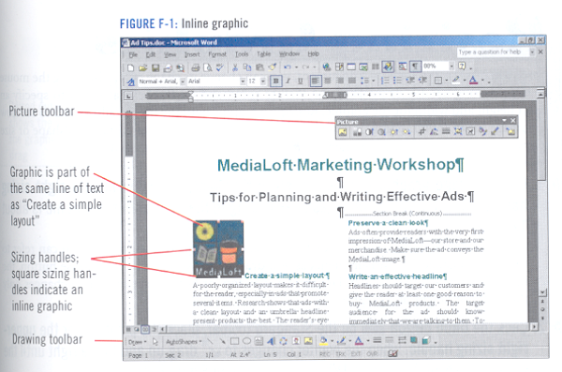
- Click the Text Wrapping button on the Picture toolbar
A menu of text wrapping styles opens.
- Click Tight
The text wraps around the sides of the graphic, as shown in Figure F-2. Notice that the sizing handles change to circles, indicating the graphic is a floating object, and an anchor and a green rotate handle appear. The anchor indicates the floating graphic is anchored to the nearest paragraph, so that the graphic will move with the paragraph if the paragraph is moved. The anchor symbol appears only when formatting marks are displayed.
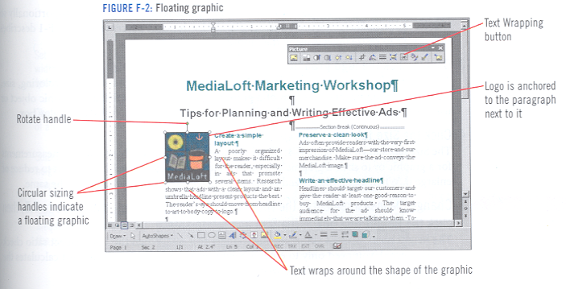
- Click the Show/Hide button, deselect the graphic, then click the Save button on the Office Icon to save your changes.

