Brainstorming Your Logo
Your logo is the face of your company and will be the number one thing your customers, competitors and pretty much everyone else on the planet associates with your business from now to forever.

Designing a cool, original, design-forward, on-brand logo isn’t as easy as you’d think, and chances are you’ll find yourself banging your head against the wall trying to come up with solid ideas.
Never fear, we’ve put together a list of tips for brainstorming logo design concepts that will knock the socks off your customers, put you a step above the competition and make you a serious contender for the logo hall of fame (ok… there’s not actually a logo hall of fame, but if there were, this list would totally help get you there):

Tip #1: Follow the rules of the brainstorm
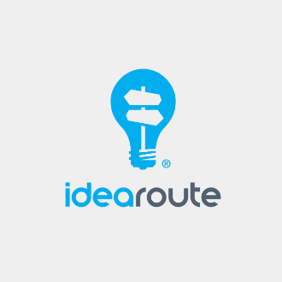
Logo Design by brandsformed® for idearoute
The process for brainstorming a logo is similar to the process for brainstorming an article outline, a business plan or a new band name—it’s all about following the rules.
So what are the rules of the brainstorm?

Don’t hold back
If you have an idea, throw it out there. Brainstorms are not the time to censor yourself. They’re the time to get everything out of your head and into the world.

Write down every idea
Write down every single idea you come up with, even if you think it’s ridiculous or silly or terrible. In a brainstorm, you want a comprehensive list of all your ideas. Got an idea that could be a serious contender for “worst idea ever?” Write it down. Sometimes bad ideas spark great conversations, which lead to great ideas.

Choose the right time
You want to brainstorm logo ideas when you’re at your creative peak, whether that’s an hour after breakfast or a few hours before you go to bed. Whenever you feel your most creative, alert and focused is when you want to schedule your brainstorm. 10 minutes after an all-you-can-eat taco buffet when you’re moments away from a food coma? Not the best time.

Let your ideas simmer
Once you’ve brainstormed a list of logo ideas, let them percolate for a while. Walk away from the list and don’t look at it again for at least 24 hours. You’d be surprised what you’ll see with a fresh pair of eyes.

Tip #2: Get clear on your branding
Logo design by CQ Design™ for Detail Geeks
If you want to end up with a logo that feels true to your brand, you need to have get super clear on what that brand actually is. What’s your brand story? Your mission? Your goals?
If you don’t know the answers to those questions right this second, that’s a-ok. Here are a few ways to find them:

Make a list of adjectives that describe your brand
Are you edgy, cool and sophisticated? Or friendly, energetic and approachable? Figure out the set of adjectives that accurately capture who you are as a brand. Start wide with 25 to 30 ideas, then narrow it down to the top five that feel like they’re the most on point for your branding.

Make a list of words that describe how you want your brand to be perceived
Do you want people to think you’re innovative and cutting-edge? Or is it more important to be viewed as trustworthy and reliable? Come up with the ideal picture of how you want to be viewed in the market—it will tell you a lot about your brand.

Make a list of how you want people to feel when they see your logo
When people see your logo, how do you want them to feel? Do you want them to be excited and energized? Or do you want them to have a sense of calm relaxation? The emotions you want to elicit in your customers and audience will tell you a lot about your brand mission and goals.

Tip #3: Figure out the logo design elements that tell your brand story
Once you’re clear on your branding, it’s time to use design to bring that story to life. But how do you decide which design elements are the right fit for your brand?
You make a design inspiration board, of course.
Inspiration boards allow you to compile all of the things you find inspiring—whether it’s a painting or a color or a logo—in one place. Then, you can look for patterns. See a lot of blue? Probably means you should incorporate blue in your logo. Notice a lot of vintage-inspired design? A vintage-inspired logo should do the trick.
When putting together your inspiration board, feel free to pull inspiration from everywhere and anywhere. Then use what inspires you to pick out patterns. These can help you identify which design elements are important to you. They might include:

Logo type
Abstract logo design by CostinLogopus | 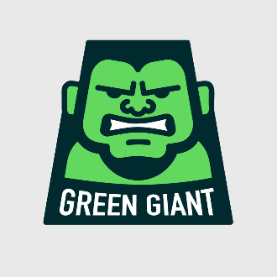  Mascot logo design by E-T
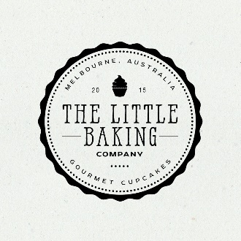  Emblem logo design by Project 4 for The Little Baking Company | 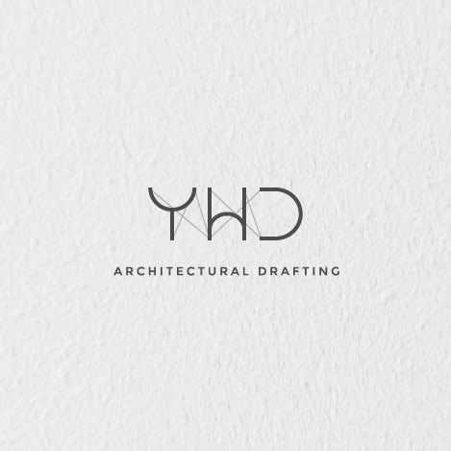  Lettermark logo design by minimalexa

See if any particular kind of logo or graphic shows up multiple times on your inspiration board; that’s a good indicator of which direction you should head with your brand.

Typography (e.g. fonts)
The font you choose for your logo can go a long way in reinforcing your branding. Take a close look at the typography that shows up on your vision board and you’ll notice the font choices typically mirror the theme and tone of the source material. Use these to choose fonts that feel true to your brand, like rounded fonts for a friendly feel, whimsical fonts if you’re going for playful and bold fonts for a more serious tone.

Color
Color is so important, and your inspiration board will likely have a few colors that reign supreme. Pay attention to those! The color palette you feature in your logo has a ton of influence on your audience and can help create specific emotions, feelings and actions. Want to instill a sense of trust with your audience? Use blue as your main color. Want people to think you’re sophisticated? Try black or gray. Want to get people to buy more? Red’s the way to go.

Style
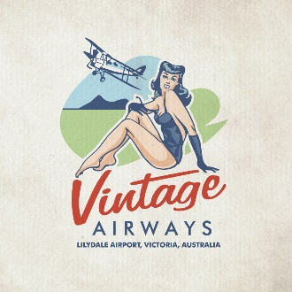  Vintage logo design by bo_rad | 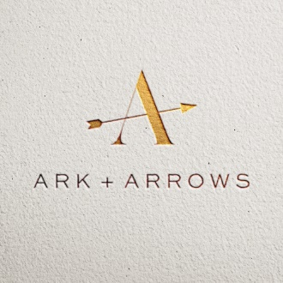  Minimalist logo design by green in blue for Ark + Arrows | 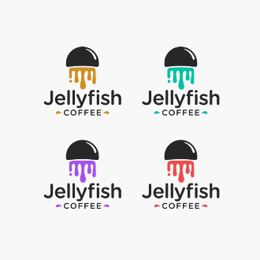  Flat art logo design by akagii for Jellyfish Coffee

The overall style of your logo is just as important as the individual elements. Your logo style can help communicate your brand personality and let your customers know what to expect from you.
Take a look at the images and graphics on your inspiration board and note any themes. Got a lot of photographs from the 50’s and 60’s? A vintage design logo can help to create a retro brand vibe. Have a lot of sleek, modern furniture that brings you inspiration? Using minimalism in your logo will mirror that sleek effect. Is your inspiration board painted with the latest gadgets and technologies? Try a flat design—which forgoes complex design features like gradients, shadows and 3D elements for an overall more simple and straightforward effect (and has been the preferred style of the tech world for the past five years).

Tip #4: Get the whole gang involved
Logo design by Desana
Game-changing ideas don’t happen in a vacuum. Different people bring different perspectives and can offer fresh ideas to incorporate into your logo, so get the whole team involved in your brainstorm.
Try bringing in people from every department in your business; people from marketing will have different ideas than people from accounting or operations or customer service. All the unique perspectives can give you more insight into how others see your brand and what you ultimately want to incorporate into your logo.
Solopreneur? No problem! There are still plenty of people you can bring in to help you brainstorm your logo. Reach out to any groups you’re a part of, like a mastermind group or an industry-specific Facebook group, to see if anyone would be willing to bounce ideas with you. If you work with a mentor, ask for their input. Ask any contractors you work with, like a virtual assistant or web designer, what they would like to see in your business logo.
If you’re truly a one-person show, try reaching out to family or friends who have experience in business and marketing; they’ll be able to give you insight from a business perspective as opposed to a personal one.

Tip #5: Brainstorm with the end in mind
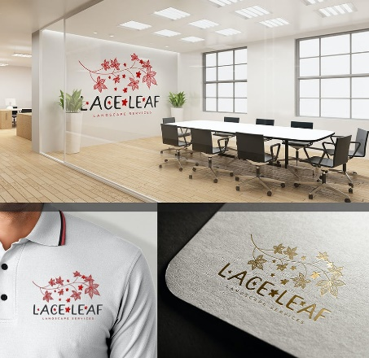
Logo design by BlindB
While you’re brainstorming, remember to keep in mind what you ultimately want to use your logo FOR. Make a list of any and every place you plan to use your logo, like your website, marketing materials or company merchandise. Then, make sure that your logo design will work across every medium, not just a select few.
Knowing where your logo is going to be used will help drive the design process. So, for example, if you know you’re going to be slapping your logo on a bunch of pens, you’ll need to make sure you can still make out all the elements of your design on that small scale.

Tip #6: Gather inspiration from the competition
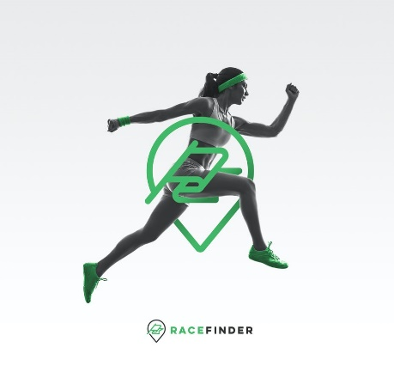
Use inspiration from your competition to propel you forward in your logo design. Logo design by sheva™
Look at who’s absolutely killing it in your market—the kind of company you aspire to be like. Then, look at their logo, and ask yourself:
- What’s working?
- What’s not?
- How can you apply what’s working to your own logo while staying true to your brand?
So, for example, let’s say you’re launching an ecommerce store selling baby products. You might notice that some of your competitors all use pastels in their logo. Or maybe they all feature a cartoon mascot. Whatever it is, you would take that common element and use it to inspire your logo design. Don’t rip off a full color palette or use the same mascot. Just use it as inspiration.

Tip #7: Think like your audience
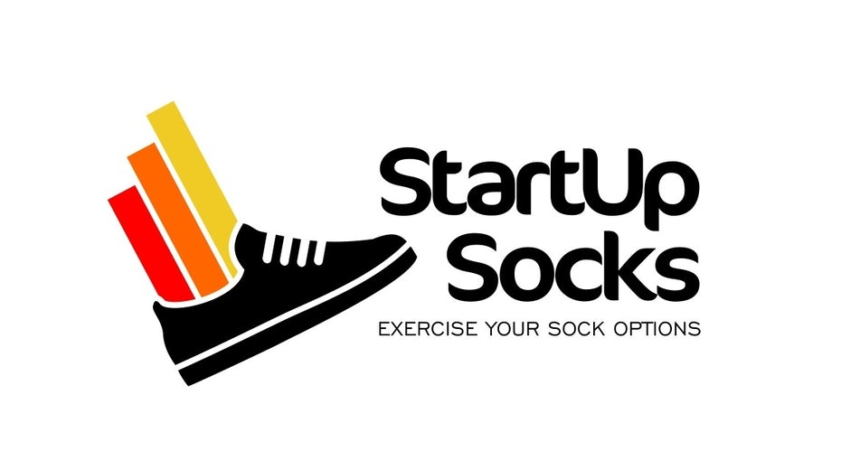
If you want to design an effective logo, you need to put yourself in your customer’s shoes. Logo design by Brain.co for StartUp Socks
When you’re designing your logo, it would behoove you to put yourself in the shoes of the person who’s going to be looking at it: your customer.
Pretend you’re a person in your target demographic and brainstorm a list of all the qualities that are important in a company you’d work with. Do you want to work with a company that’s reliable and delivers high quality customer service? Do you want to work with a fun, edgy brand that’s challenging the status quo?

Tip #8: Look for opportunities for subliminal messaging
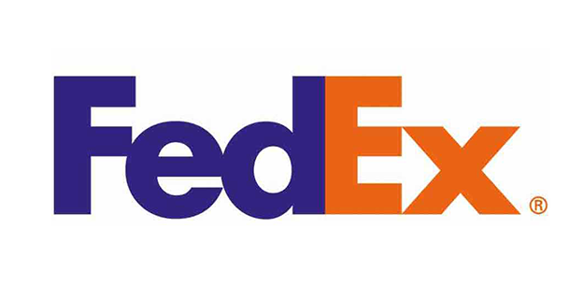
See that arrow? That’s what we call subliminal messaging. Well played, FedEx.
Sometimes the best logo design elements are the ones you don’t immediately see, like the arrow between the “e” and the “x” in the FedEx logo that subtly hints they’ll get your package to where it needs to go or the dash that looks like a smile in the Amazon logo which hints you’ll be happy with your customer experience.
Make a list of your brand values. Are you all about speed and efficiency? Or maybe your brand is focused on friendliness and accessibility. Whatever they are, brainstorm your brand values and give them to your designer; they can come up with imagery that matches those values and think of ways to subtly incorporate them into your logo design.
With these logo brainstorming tips, you’re well on your way to designing a logo that will put your brand’s best face forward.

