How Does a Search Engine Work?
Before a search engine can tell you where a file or document is, it must be found. To find information on the hundreds of millions of Web pages that exist, a search engine employs special software robots, called spiders, to build lists of the words found on Web sites. When a spider is building its lists, the process is called Web crawling. In order to build and maintain a useful list of words, a search engine's spiders have to look at a lot of pages.
How does any spider start its travels over the Web? The usual starting points are lists of heavily used servers and very popular pages. The spider will begin with a popular site, indexing the words on its pages and following every link found within the site. In this way, the spidering system quickly begins to travel, spreading out across the most widely used portions of the Web.
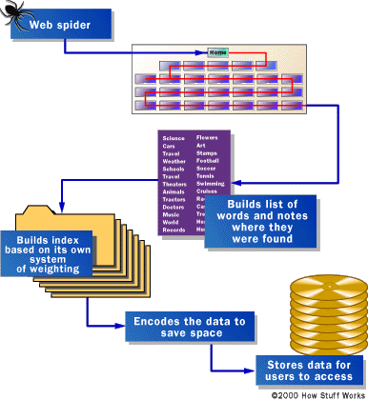
"Spiders" take a Web page's content and create key search words that enable online users to find pages they're looking for.

