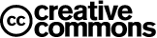
"Creative Commons is a non-profit that offers an alternative to full copyright."

creativecommons.org

Briefly...
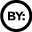Attribution means:
You let others copy, distribute, display, and perform your copyrighted work - and derivative works based upon it - but only if they give you credit.
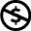Noncommercial means:
You let others copy, distribute, display, and perform your work - and derivative works based upon it - but for noncommercial purposes only.
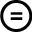No Derivative Works means:
You let others copy, distribute, display, and perform only verbatim copies of your work, not derivative works based upon it.
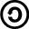Share Alike means:
You allow others to distribute derivative works only under a license identical to the license that governs your work.

